##### SMART AGRICULTURE MANAGEMENT SYSTEM

##### A PROJECT REPORT

###### **Submitted by**

##### Madhur Rai (22BCE11165)

**Sasi Kumar(22BCE11638)**

**Mukund Maheshwari(22BCE10624)**

**Devansh Maheshwari(22BCE11281)**

**Akshat Bansal(22BCE10341)**

*in partial fulfillment for the award of the degree*

*of*

##### BACHELOR OF TECHNOLOGY

**in**

**COMPUTER SCIENCE AND ENGINEERING**



**SCHOOL OF COMPUTING SCIENCE AND ENGINEERING**

**VIT BHOPAL UNIVERSITY**

**KOTHRIKALAN, SEHORE**

**MADHYA PRADESH - 466114**

OCTOBER 2023

**VIT BHOPAL UNIVERSITY,KOTHRIKALAN, SEHORE**

**MADHYA PRADESH – 466114**

**BONAFIDE CERTIFICATE**

Certified that this project report titled **“SMART AGRICULTURE MANAGEMENT SYSTEM”** is the bonafide work of “**Madhur Rai (Register No :22BCE11165), Sasi Kumar (Register No :22BCE11638), Mukund Maheswari (Register No :22BCE10624), Devansh Maheswari (Register No :22BCE11281), Akshat Bansal (Register No :22BCE10341) ”,** who carried out the project work under my supervision. Certified further that to the best of my knowledge the work reported here does not form part of any other project / research work on the basis of which a degree or award was conferred on an earlier occasion on this or any other candidate.

**PROJECT SUPERVISOR**

Dr.Vijendra Singh Bramhe, Assistant Professor Senior Grade 1

School of Computer Science and Engineering

VIT BHOPAL UNIVERSITY

The Project Exhibition I Examination is held on \_\_\_\_\_\_\_\_\_\_\_\_\_\_\_

**ACKNOWLEDGEMENT**

First and foremost I would like to thank the Lord Almighty for His presence and immense blessings throughout the project work.

I wish to express my heartfelt gratitude to Dr Sandip Mal, Program Chair, School of Computer Science And Engineering for much of his valuable support encouragement in carrying out this work.

I would like to thank my internal guide Mr. Vijendra Singh Bramhe, for continually guiding and actively participating in my project, giving valuable suggestions to complete the project work.

I would like to thank all the technical and teaching staff of the School of Computer Science And Engineering, who extended directly or indirectly all support.

Last, but not the least, I am deeply indebted to my parents who have been the greatest support while I worked day and night for the project to make it a success.

# ABSTRACT

“Agriculture Management System” provides the farmers with a lot of features and latest updates on technologies that are running around the globe and producing great yeild of crops . The main objective of this project is building an website which will help the farmers to get every necessary knowledge, detail and various features that can help them to perform safe and smart organic farming using the website.

Agricultural Management System is an online website where farmers can go through the list of calculators and features and articles uploaded by the farmer and can check the government schemes supporting organic farming. Both farmers and admin need to login separately using their own user id and password. And the admin can manage the database whereas farmers can store their data of crops . This application is developed using DJANGO, HTML,CSS,JSand MYSQL programming language.

The Trends of the crops act so that these will be pretty important to the users who access these via the internet, The main features of the information system includes information retrival facilities for users from anywhere in the form of obtaining statistical information about fertilizer, research institutes and researches.

The features include the use of weather API that gives the detailed weather description of the city. Another feature using machine learning model includes Soil Classification System that can classify soil types and according to the soil type suggests crops and various information.

In addition This provides individual information about Intercrops related to main crops. The system allows the retrieving facilities but also the updating facilities to the authorized persons in the corresponding institutes.

**CONTENTS**

Declaration

Abstract

Acknowledgement

Contents

List of Figures

List of Tables

**Chapter No**

**Chapter Title**

**Page No**

|  |  |  |
| --- | --- | --- |
| **1 INTRODUCTION** | | **1-3** |
| 1.1 History of the Agric  1.1.1 Objectives  1.1.2 Outcom  1.2 DEFINATION | ulture management system.  es,Outcomes | 1  1  2  3 |
| **3** | **TASK PERFORMED** | 4 |
|  |  |  |
| **4** | **REFLECTION NOTES** | 5-21 |

1. Experience 5
2. Technical Outcomes 6

i

1. System Analysis and Design 8
   1. Existing System 8
   2. Disadvantages of the Existing System 8
   3. Proposed System 8
   4. Advantages of the Proposed System 8
   5. Studies 9-20
   6. Flow Chart 21-24

|  |  |  |  |
| --- | --- | --- | --- |
| 7. LiteratureReview  8. Implementation  9. Screen Shots | 1. Modules |  | 24  17  18 |
| **5** |  | **CONCLUSION** | 22 |
|  |  |  |  |
|  |  | **BIBLIOGRAPHY** | 23 |
|  |  |  |  |
|  |  | **APPENDIX** | 24 |

Appendix A: Abbreviations

# INTRODUCTION

**1.1 History of the Agriculture management system:**

Organic farming has a rich history rooted in sustainable agricultural practices. Originating as a reaction against conventional farming methods, the organic movement gained momentum in the mid-20th century. Understanding this historical context is crucial for navigating the challenges faced by modern organic farmers.

The history of agricultural system modeling is characterized by a number of key events and drivers that led scientists from different disciplines to develop and use models for different purposes (Fig. 1). Some of the earliest agricultural systems modeling (Table 1) were done by Earl Heady and his students to optimize decisions at a farm scale and evaluate the effects of policies on the economic benefits of rural development (Heady, 1957, Heady and Dillon, 1964). This early work during the 1950s through the 1970s inspired additional economic modeling. Dent and Blackie (1979) included models of farming systems with economic and biological components; their book provided an important source for different disciplines to learn about agricultural systems modeling. Soon after agricultural economists started modeling farm systems, the International Biological Program (IBP) was created. This led to the development of various ecological models, including models of grasslands during the late 1960s and early 1970s, which were also used for studying grazing by livestock. The IBP was inspired by forward-looking ecological scientists to create research tools that would allow them to study the complex behavior of ecosystems as affected by a range of environmental drivers (Worthington, 1975, Van Dyne and Anway, 1976).

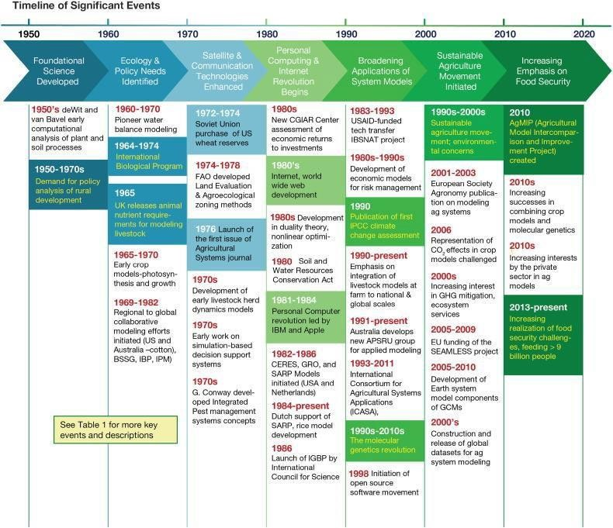

**Table 1**

**Timeline of key events that shaped the development and use of agricultural system models.**

|  |  |  |
| --- | --- | --- |
| **Year** | **Event** | **Impacts** |
| |  |  |  | | --- | --- | --- | | 1940s–1950s | [de Wit (1958)](https://www.ncbi.nlm.nih.gov/pmc/articles/PMC5485640/#bb0215) and [van Bavel (1953)](https://www.ncbi.nlm.nih.gov/pmc/articles/PMC5485640/#bb0860) develop early computational analyses of plant and soil processes; Development of nutritional requirement tables for cattle ([NRC, 1945](https://www.ncbi.nlm.nih.gov/pmc/articles/PMC5485640/#bb0615)) | Foundation established for the application of simulation and operations research optimization in plant-soil systems research and for modeling farm animal responses to nutrients | | 1950–1970s | Demand for policy analysis of rural development | Representative farm optimization models were developed and applied by Heady and students at Iowa State University, thus establishing use of linear programming methods for agricultural production | | 1960–1970 | Pioneers in soil water balance modeling (WATBAL) [([Slatyer, 1960](https://www.ncbi.nlm.nih.gov/pmc/articles/PMC5485640/" \l "bb0775), [Slatyer, 1964](https://www.ncbi.nlm.nih.gov/pmc/articles/PMC5485640/" \l "bb0780), [Keig and McAlpine, 1969](https://www.ncbi.nlm.nih.gov/pmc/articles/PMC5485640/#bb9600); [Ritchie, 1972](https://www.ncbi.nlm.nih.gov/pmc/articles/PMC5485640/#bb0685); [McCown, 1973](https://www.ncbi.nlm.nih.gov/pmc/articles/PMC5485640/#bb0545))] | Water balance models proved to be useful in the evaluation of climatic constraints to agricultural development. Foundations for linking soil and plant models established. | | 1964–1974 | International Biological Program | Strong emphasis on large scale ecological and environmental studies led to development of grassland ecosystem models; laid foundation for ongoing work today | | 1965 | UK releases nutrient requirement tables for ruminants ([ARC, 1965](https://www.ncbi.nlm.nih.gov/pmc/articles/PMC5485640/#bb0070), first work since the 50s) | Very influential publication; subsequent development of feeding systems models throughout Europe. | | 1965–70 | Early crop modeling pioneers develop photosynthesis and growth models (C. T. de Wit, W. G. Duncan, R. Loomis) | Captured imagination of many crop and soil scientists. Prompted many to follow in their steps. | | 1969–75 | S-69 Cotton Systems Analysis Project ([Bowen et al., 1973](https://www.ncbi.nlm.nih.gov/pmc/articles/PMC5485640/#bb0155), [Stapleton et al., 1973](https://www.ncbi.nlm.nih.gov/pmc/articles/PMC5485640/#bb0790), [Jones et al., 1974](https://www.ncbi.nlm.nih.gov/pmc/articles/PMC5485640/#bb0470), [Jones et al., 1980](https://www.ncbi.nlm.nih.gov/pmc/articles/PMC5485640/#bb0460), [Baker et al., 1983](https://www.ncbi.nlm.nih.gov/pmc/articles/PMC5485640/#bb0075)) | Prompted development of several cotton models (W. G. Duncan, J. D. Hesketh, D. Baker, J. Jones, J. McKinion) | | 1971 | Creation of the Biological System Simulation Group (BSSG) | Led to self-supported annual workshops aimed at advancing cropping system and other biological system models, continuing through 2014 | | 1970s and early 80s | Development of early herd dynamics simulation models ([Freer et al., 1970](https://www.ncbi.nlm.nih.gov/pmc/articles/PMC5485640/#bb0305), [IADB, 1975](https://www.ncbi.nlm.nih.gov/pmc/articles/PMC5485640/#bb0415), [Davis et al., 1976](https://www.ncbi.nlm.nih.gov/pmc/articles/PMC5485640/#bb0210), [ILCA, 1978](https://www.ncbi.nlm.nih.gov/pmc/articles/PMC5485640/#bb0420), [Sanders and Cartwright, 1979](https://www.ncbi.nlm.nih.gov/pmc/articles/PMC5485640/#bb0760), [Konandreas and Anderson, 1982](https://www.ncbi.nlm.nih.gov/pmc/articles/PMC5485640/" \l "bb0505)) | Established in the developed world but some early examples in the developing world. Crucial for the advancement of whole livestock farm modeling and for representing disease and reproductive impacts | | 1970s | Gordon Conway develops concept of IPM in Malaysia. Huffaker Integrated Pest Management (IPM) Project begins in USA, evolves into the Consortium for IPM, ending in 1985. Global emphasis on reducing pesticide use, due to major increases in pesticide use globally and resistance in target pest populations. | Insect and disease models developed and used to help establish economic thresholds and to predict timing of threshold exceedance; some pest models were linked with crop models | | Mid 1970s | Discovery of chaos in ecological systems by Robert May ([May, 1976](https://www.ncbi.nlm.nih.gov/pmc/articles/PMC5485640/#bb0540)) and related advances in theoretical population ecology | Led to new approaches to modeling predator-prey, host-disease interactions | | 1972–74 | Soviet Union purchase of US wheat reserves, causing major price spike (see [Pinter et al., 2003](https://www.ncbi.nlm.nih.gov/pmc/articles/PMC5485640/#bb0660)) | US Government created LACIE, AGRISTARS projects to develop and use crop models with remote sensing to obtain strategic crop forecasts. Led to development of CERES-Wheat and CERES-Maize models (first published in 1986) | | 1974–1978 | FAO development of Land Evaluation Framework in 1974 and an automated Agro-Ecological Zoning (AEZ) in 1978. ([FAO, 1976](https://www.ncbi.nlm.nih.gov/pmc/articles/PMC5485640/#bb0265), [FAO, 1978–81](https://www.ncbi.nlm.nih.gov/pmc/articles/PMC5485640/#bb0270)) | Provided first methodology for land evaluation on a global basis, integrating soil, climate, vegetation, and socio-economic factors, leading to many applications and efforts to improve integrated assessment approaches | | 1975–1982 | Early pioneers in computer simulation based decision support — SIROTAC and Australian Cotton Industry ([CSIRO, 1980](https://www.ncbi.nlm.nih.gov/pmc/articles/PMC5485640/#bb0200)); S-107 Project on soybean modeling in the US | The Australian cotton modeling was the first major initiative to put crop and pest models in the hands of farmers for decision support. The soybean project in the US led to development of two major soybean models SOYGRO ([Wilkerson et al., 1983](https://www.ncbi.nlm.nih.gov/pmc/articles/PMC5485640/#bb0920)) and GLYCIM ([Acock et al.,1985](https://www.ncbi.nlm.nih.gov/pmc/articles/PMC5485640/" \l "bb9100)). | | 1976 | Launch of the first issue of Agricultural Systems, edited by C. R. W. Spedding ([Spedding, 1976](https://www.ncbi.nlm.nih.gov/pmc/articles/PMC5485640/#bb0785)) | This journal helped legitimize agricultural system modeling, providing a place for scientists to publish their agricultural systems modeling and analyses as well as a collection of scholarly work in this area. This journal continues today with impact factor of about 2.5 | | 1979 | E.R. Orskov establishes the ‘Dacron bag technique’ for measuring the degradability of feed in the rumen ([Orskov and McDonald, 1979](https://www.ncbi.nlm.nih.gov/pmc/articles/PMC5485640/#bb0620)) | Very influential method developed for characterizing the nutritional value of feeds, opening possibilities of new types of models; a new era of dynamic feed characterization started, leading to better animal models | | 1980 | Soil and Water Resources Conservation Act analysis for 1980, mandate to develop a model to predict impacts of soil erosion on crop productivity | The comprehensive soil-cropping system model, (EPIC, the Environmental Policy Integrated Climate model), was developed to estimate soil productivity as affected by erosion | | 1980s | Growth of CGIAR Centers creates demand for assessment of economic returns to investments in agricultural research | Market surplus methods developed for estimating economic returns to investments, demonstrating high returns to agriculture research investment | | 1981–1984 | Personal computer (PC) revolution led by IBM introduction of its Model 5150 personal computer and the first Apple Mac computer in 1984 | These new PCs led to major increases in individual access to computer power; many agricultural models began appearing on PCs | | 1981 | Development of the first soil nitrogen (N) model for predicting crop responses under both water and N limiting conditions ([Seligman and van Keulen, 1981](https://www.ncbi.nlm.nih.gov/pmc/articles/PMC5485640/#bb0770)) | This model was the foundation for future soil N models in APSIM, DSSAT, and other suites of crop models | | 1980s through early 1990s | Development and growth of the Internet that began to connect computers globally | Ushered in new era of global communication and information technologies that has affected all areas of our lives, including agricultural system model development and use | | 1982 to 1986 | CERES Models (Maize and Wheat) and GRO (SOYGRO and PNUTGRO) models were developed ([Wilkerson et al., 1983](https://www.ncbi.nlm.nih.gov/pmc/articles/PMC5485640/#bb0920), [Boote et al., 1986](https://www.ncbi.nlm.nih.gov/pmc/articles/PMC5485640/#bb0125)) | The CERES models linked soil water, soil nitrogen and crop growth and yield together in a comprehensive fashion for the first time. They stimulated interest and activity in crop modeling in many parts of the world. | | 1980s | Development of duality theory and advances in nonlinear optimization via development of GAMS by World Bank | Led to advances in applications of econometric methods for production model estimation and to national and regional policy analysis models; use of new entropy methods reduced data requirements for the models | | 1980–1990 | Influential developments in pasture modeling (Hurley pasture model — [Johnson and Thornley, 1983](https://www.ncbi.nlm.nih.gov/pmc/articles/PMC5485640/#bb0485) and the SAVANNA model ([Coughenour et al., 1984](https://www.ncbi.nlm.nih.gov/pmc/articles/PMC5485640/#bb9400)) | Led to a proliferation of pasture models for intensive temperate and tropical grasslands and savanna systems. These models simulated herbage mass and accounted for sward components, which led to a more sophisticated representation of grazing processes. | | 1983–1993; DSSAT continuing today | USAID funded international IBSNAT project for facilitating technology transfer using systems approaches and crop and soil models | This led to the creation of the DSSAT suite of crop models that combined the CERES family of models with the SOYGRO and PNUTGRO models. The availability of the IBSNAT guidelines for data collection for crop modeling strengthened the crop model testing effort around the world. | | 1984 –continuing today | Dutch Government funding of the SARP (Systems Analysis of Rice Production) project at IRRI in the Philippines. | Development of a dynamic rice model that later was named ORYZA, which is still widely used today ([Penning de Vries et al., 1991](https://www.ncbi.nlm.nih.gov/pmc/articles/PMC5485640/#bb0650)) | | 1985–1992 | Earliest application of crop-soil systems models in a developing country “research for development” context — Kenya-Australia Dryland Farming Systems Project ([McCown et al., 1992](https://www.ncbi.nlm.nih.gov/pmc/articles/PMC5485640/#bb0555), [Keating et al., 1991](https://www.ncbi.nlm.nih.gov/pmc/articles/PMC5485640/#bb0495)) | First PC used in agricultural research in Kenya running CERES Maize (influenced strongly by the IBSNAT minimum data set guidance) in 1985. Formed the foundation for modeling low input subsistence agricultural systems and exploring development opportunities. This experience went on to strongly influence the evolution of the APSIM farming systems simulator. | | 1986 | Launch of the IGBP (International Geosphere-Biosphere Program) by the International Council for Science (ICSU) | Brought attention to the planet under pressure, including climate change, and helped coordinate research at regional and global scales on interactions of Earth's biological, chemical, physical, and human systems, including influence on ecosystem modeling | | 1970s–1980s | Development of optimization and econometric methods for application to production risks | Broadened analysis of production to include risk management behavior (see [Anderson et al., 1977](https://www.ncbi.nlm.nih.gov/pmc/articles/PMC5485640/#bb0025), [Just and Pope, 1978](https://www.ncbi.nlm.nih.gov/pmc/articles/PMC5485640/#bb0490), [Antle, 1983](https://www.ncbi.nlm.nih.gov/pmc/articles/PMC5485640/#bb0030), [Antle, 1987](https://www.ncbi.nlm.nih.gov/pmc/articles/PMC5485640/#bb0035)) | | 1980s until now | Modeling herd replacement decisions with dynamic programming ([Van Arendonk and Dijkhuizen, 1985](https://www.ncbi.nlm.nih.gov/pmc/articles/PMC5485640/#bb0855)) | As computer power increased, more complex applications attempting to optimize intensive and industrial livestock production occurred. | | 1990 | Publication of the first Intergovernmental Panel on Climate Change ([IPCC, 1990](https://www.ncbi.nlm.nih.gov/pmc/articles/PMC5485640/#bb0435)) Assessment Report | Led to first use of crop and economic models for climate change impact assessments on crops at field to global-scales (e.g., [Curry et al., 1990](https://www.ncbi.nlm.nih.gov/pmc/articles/PMC5485640/#bb0205), [Rosenzweig and Parry, 1994](https://www.ncbi.nlm.nih.gov/pmc/articles/PMC5485640/#bb0720)); led to broad use of agricultural and ecological models that estimate GHG emissions and carbon dynamics and economic models for assessing impacts of climate change on agriculture | | 1990s until now | The era of livestock systems model integration ([Herrero et al., 1996](https://www.ncbi.nlm.nih.gov/pmc/articles/PMC5485640/#bb0365), [Herrero et al., 1999](https://www.ncbi.nlm.nih.gov/pmc/articles/PMC5485640/#bb0375), [Freer and Donnelly, 1997](https://www.ncbi.nlm.nih.gov/pmc/articles/PMC5485640/#bb0310)) | Many soft ‘modular’ couplings of simulation models of individual animal performance, herd dynamics, pasture and crop models happened at this time. | | 1990–1994 | First studies on global impacts of potential climate change on agricultural systems ([Rosenzweig and Parry, 1994](https://www.ncbi.nlm.nih.gov/pmc/articles/PMC5485640/#bb0720)) | These were the first studies making broad use of crop and economic models for global impacts. These studies paved the way for many other national and global impact studies of climate change impacts and adaptation. | | 1991–continuing today | Australian governments develop a new APSRU group for modeling agricultural systems for practical uses | This led to the now widely used APSIM ([McCown et al., 1996](https://www.ncbi.nlm.nih.gov/pmc/articles/PMC5485640/#bb0560), [Keating et al., 1991](https://www.ncbi.nlm.nih.gov/pmc/articles/PMC5485640/#bb0495), [Keating et al., 2003](https://www.ncbi.nlm.nih.gov/pmc/articles/PMC5485640/#bb0500)) suite of cropping system models which drew on early experience with CERES, EPIC and PERFECT models but re-engineered the “farming systems” foundations. | | 1992 | Comprehensive, model-based scenario analysis funded by the European Union for policy decisions | Grounds for Choice published ([Netherlands Scientific Council for Government Policy, 1992](https://www.ncbi.nlm.nih.gov/pmc/articles/PMC5485640/#bb0610)). Grounds for Choice. | | 1992 | The Cornell Net Carbohydrate and Protein System is launched ([Russell et al., 1992](https://www.ncbi.nlm.nih.gov/pmc/articles/PMC5485640/#bb0750)) | The CNCPS became the first commercially available dynamic model of digestion in ruminants. Its development influenced the current livestock performance models in many parts of the world. | | 1993–2011 | International Consortium for Agricultural Systems Applications (ICASA), formed in 1993, ended in 2011 | Helped crop modelers collaborate to develop standards for input data for crop models ([Hunt et al., 1994](https://www.ncbi.nlm.nih.gov/pmc/articles/PMC5485640/#bb0410)), leading later to the ICASA data dictionary and data standards ([White et al., 2013](https://www.ncbi.nlm.nih.gov/pmc/articles/PMC5485640/#bb0915)), now used in harmonizing model inputs in AgMIP project ([White et al., 2013](https://www.ncbi.nlm.nih.gov/pmc/articles/PMC5485640/#bb0915)). | | 1998 | Initiation of open source software movement, leading to more collaborative software development | Led to interest in providing open-source versions of widely-used crop simulation models; now being done by some ag system modelers (e.g., APSIM, DSSAT). | | 1999 | The Livestock Revolution study ([Delgado et al., 1999](https://www.ncbi.nlm.nih.gov/pmc/articles/PMC5485640/#bb0220)) | Key analysis explaining projected growth of livestock sector showing that ‘as people get richer and societies urbanize they consume more livestock’. Led to acknowledgement of need for increased understanding of livestock sector for agricultural development. | | 1980s–1990s | Interest in trade liberalization | Led to quantitative analysis of trade policies and development of national and global agricultural trade policy models. | | 1990s–2010s | The molecular genetics revolution: Genome sequencing technological advances and advances in understanding of the functions of crop and animal genes; ability to genotype new lines and breeds | Led to still evolving efforts by various public crop modeling groups and by seed companies to connect ecophysiological crop models for plant breeding and management purposes (e.g., see [White and Hoogenboom, 1996](https://www.ncbi.nlm.nih.gov/pmc/articles/PMC5485640/#bb0910), [Hoogenboom and White, 2003](https://www.ncbi.nlm.nih.gov/pmc/articles/PMC5485640/#bb0400), [Hammer et al., 2006](https://www.ncbi.nlm.nih.gov/pmc/articles/PMC5485640/#bb0335), [Messina et al., 2006](https://www.ncbi.nlm.nih.gov/pmc/articles/PMC5485640/#bb0565)). | | 1990s–2000s | Sustainable agriculture movement; greater concern on environmental consequences of agriculture | Led to incorporation of biophysical processes into farm household, econometric and programming approaches; also led to development of “tradeoff analysis” approach; spatial data and tools increasingly used to develop spatially explicit biophysical and economic models | | Late 1990s–2000s | Construction and release of global datasets of cropping areas, sowing dates and yields ([Ramankutty and Foley, 1999](https://www.ncbi.nlm.nih.gov/pmc/articles/PMC5485640/" \l "bb0670), [Ramankutty et al., 2008](https://www.ncbi.nlm.nih.gov/pmc/articles/PMC5485640/" \l "bb0675)) | Allowed researchers to run simulations at finer resolution over greater model domains with more clearly documented assumptions and inputs. | | 2000s | Increasing interest in greenhouse gas (GHG) mitigation and the importance of ecosystem services | Led to models for analysis of mitigation of GHG in agriculture via soil C sequestration, afforestation, reduced livestock emissions; also led to linkages of economic models with crop, livestock, hydrology, and ecosystem models. | | 2001–2003 | European Society Agronomy meeting hosts special session on modeling cropping systems. Published as Volume 18 European Journal Agronomy | This meeting led to a special issue of European Journal of Agronomy (vol 18) in which comprehensive papers on the major modeling systems, namely DSSAT, APSIM, CROPSYST, STICS, Wageningen models. Over 2000 citations for models in this publication. | | 2006 | Representation of CO2 effects in crop model simulations challenged by [Long et al. (2006)](https://www.ncbi.nlm.nih.gov/pmc/articles/PMC5485640/#bb0530) | Opened a debate between plant experimenters and modelers on the skill of crop models for yield prediction in future climates; prompted interest in more evaluations of CO2 effects interacting with temperature, other factors | | 2005–2009 | European Union funding of the System for Environmental and Agricultural Modeling: Linking European Science and Society (SEAMLESS) | This led to major collaboration across Europe for developing models for use across scales, from field to farm, country, and EU levels. | | 2005–2010 | Development of Earth system models, components of general circulation models (GCMs) | Led to new methods for coupling crop simulation models to land surface schemes of numerical climate models ([Challinor et al., 2004](https://www.ncbi.nlm.nih.gov/pmc/articles/PMC5485640/#bb0175)). | | 2006 | FAO Livestock's Long Shadow report ([Steinfeld et al., 2006](https://www.ncbi.nlm.nih.gov/pmc/articles/PMC5485640/#bb0795)) | Demonstrated the large environmental footprint of livestock leading to programs for assessing and reducing the environmental impacts of livestock. Most of this work was done through modeling. | | Mid 2005s onwards | Development of global livestock models ([Bouwman et al., 2005](https://www.ncbi.nlm.nih.gov/pmc/articles/PMC5485640/#bb0150), [FAO, 2013](https://www.ncbi.nlm.nih.gov/pmc/articles/PMC5485640/#bb0275), [Herrero et al., 2013](https://www.ncbi.nlm.nih.gov/pmc/articles/PMC5485640/#bb0385)) | Global integrated assessment of livestock systems now possible at high resolution including land use, emissions, economics, biomass use and others ([Havlik et al., 2014](https://www.ncbi.nlm.nih.gov/pmc/articles/PMC5485640/#bb0345), [Cohn et al., 2014](https://www.ncbi.nlm.nih.gov/pmc/articles/PMC5485640/#bb0185), [PBL Netherlands Environmental Assessment Agency, 2013](https://www.ncbi.nlm.nih.gov/pmc/articles/PMC5485640/#bb0645), [Bouwman et al., 2013](https://www.ncbi.nlm.nih.gov/pmc/articles/PMC5485640/#bb0145) and others) and their links to other sectors (crops, forestry, energy, etc.). | | 2010 | Creation of the Agricultural Model Intercomparison and Improvement Project (AgMIP), a global program and community of agricultural scientists | This initiative led to model comparisons and initiatives for improving models, capturing the imagination and interest of agricultural modelers worldwide ([Rosenzweig et al., 2013a](https://www.ncbi.nlm.nih.gov/pmc/articles/PMC5485640/#bb0725), [Rosenzweig et al., 2013b](https://www.ncbi.nlm.nih.gov/pmc/articles/PMC5485640/#bb0730), [Asseng et al., 2013](https://www.ncbi.nlm.nih.gov/pmc/articles/PMC5485640/" \l "bb0065)). | | 2010s | Increasing interests by the private sector in agricultural system models | Some companies create their own crop modeling teams, others start working in public-private collaborations. | | 2010s | With the food price shock of 2008/2010, a realization of the need to increase food production to meet needs of 10 billion by 2050, including challenges of climate change and sustainable natural resources | This realization is leading to greater interest in use of new ICT developments (e.g., cloud computing, smart phones, app stores, mobile computing, use of UAVs for agricultural management) and agricultural system models to help guide investments and development and to greater interest by the private sector. | | | |

Agriculture Management System

**1.Objectives**

The primary objectives of this research project are to:

•Evaluate and address the challenges faced by organic farmers in soil fertility management.

•Develop innovative approaches for effective pest control in organic farming.

•Explore strategies to enhance the market competitiveness of organic produce.

## 1.2 Project Outcomes

The expected outcomes include:

* Practical solutions for sustainable soil fertility management in organic farming.
* Novel approaches for integrated pest management tailored to organic practices.
* Recommendations for improving the market presence and economic viability of organic products.

# 2.Definition

Organic farming, while recognized for its environmental and health benefits, faces multifaceted challenges in contemporary agricultural practices. Issues such as soil fertility management, pest control, and market competitiveness require a nuanced understanding and innovative solutions.

**Literature Review :**

**Work done by other institutions:**

**Study-1**

* Based on the latest studies, more than 13,000 chemicals have been identified as associated with plastics and plastic production across a wide range of applications.
* Ten groups of chemicals (based on chemistry, uses, or sources) are identified as being of major concern due to their high toxicity and potential to migrate or be released from plastics, including specific flame retardants, certain  UV stabilizers,  per- and polyfluoroalkyl substances (PFASs), phthalates, bisphenols, alkylphenols and alkylphenol ethoxylates, biocides, certain metals and metalloids, polycyclic aromatic hydrocarbons, and many other non-intentionally added substances (NIAS).
* Chemicals of concern have been found in plastics across a wide range of sectors and products value chains, including toys and other children's products, packaging (including food contact materials), electrical and electronic equipment, vehicles, synthetic textiles and related materials, furniture, building materials, medical devices, personal care and household products, and agriculture, aquaculture and fisheries.
* Chemicals of concern in plastics can impact our health and our environment: Extensive scientific data on the potential adverse impacts of about 7,000 substances associated with plastics show that more than 3,200 of them have one or more hazardous properties of concern.
* Women and children are particularly susceptible to these toxic chemicals. Exposures can have severe or long-lasting adverse effects on several key period of a women’s life and may impact the next generations. Exposures during fetal development and in children can cause, for example, neurodevelopmental / neurobehavioural related disorders. Men are not spared either, with latest research documenting substantial detrimental effects on male fertility due to current combined exposures to hazardous chemicals, many of which are associated with plastics.
* Chemicals of concern can be released from plastic along its entire life cycle, during not only the extraction of raw materials, production of polymers and manufacture of plastic products, but also the use of plastic products and at the end of their life, particularly when waste is not properly managed, finding their way to the air, water and soils.
* Existing evidence calls for urgent action to address chemicals in plastics as part of the global action on plastic pollution, to protect human health and the environment, and transition to a toxic-free and sustainable circular economy.

UNEP acknowledges the financial support from the Government of Norway, the Government of Sweden and the Government of Switzerland, for the development of the report.

**Study-2**

* **Improvement in Agricultural Output Viz Productivity:**  
  + Area- agricultural output has to be increased **through access to irrigation and technological advancement.**
* **Resource use efficiency or saving in cost of production:**
  + Increase in **cropping intensity**, i.e., the ratio of Net Area Sown to the Total Cropped Area - by raising **short-duration** crops after the main Kharif and after the main [**Rabi season**](https://www.drishtiias.com/daily-updates/daily-news-analysis/rabi-crops)so that agricultural land does not remain unused for half of the productive period.
* **Diversification:**
  + Towards high value crops like fruits, vegetables, fiber, condiments & spices and sugarcane.
  + Towards other allied enterprises like forestry, dairing rather than depending primarily on crop cultivation.
* **Shifting Cultivators to Non-Farm Occupations:**
  + Non-farm sectors **provide 2.76 times more productive employment than agriculture sector in rural areas.**
* **Improvement in terms of trade for Farmers:**
  + Use of**CPIAL (Consumer price index for agricultural labour)** as a deflator to change nominal farm income to real farm income.

Analysis of Farmers' Income: What is the Scenario?

* **Current Scenario of the Income:**
  + The benchmark estimated **annual income was Rs 96,703 in 2015-16** which was taken as a **base year.** This comes to Rs 8,059 per month. As such, the target income for doubling by 2022 is**Rs 21,146 per month (taking inflation also into account).**
    - However, the estimated monthly income of farm households in 2018-19 was Rs 10,218 per month in nominal terms. It is nowhere near the target of Rs 21,146 per month.
  + As per the survey results, conducted by the[**National Sample Survey Office (NSSO),**](https://www.drishtiias.com/daily-news-analysis/restructuring-of-indian-statistical-system) the average monthly income per agricultural household, from all sources, was estimated at **Rs 10,218 when compared to Rs 6,426 in 2012-13.**
    - In other words, the **farm income had risen by 59% till 2019. But, in this period, their earnings came more from wages than from crop production in 2018-19.**

[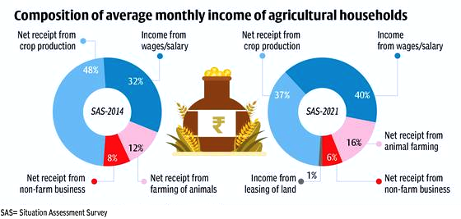](http://drishtiias.com/images/uploads/1665386279_Agriculture_Household_Drishti_IAS_English.png)

* **Farmers’ Earnings:**
  + The 77th NSS round data, in 2018-19, showed that the average monthly income has gone up, of which the**highest income comes from wages, followed by income from crop cultivation and production.**
    - There is a substantial rise in income from animal farming.
  + The farmers are also earning **comparatively higher income from non-farm businesses and are leasing out land.**
    - Income from wages was 32% in 2012-13 which was recorded to be 40% in 2018-19. This implies that farmers are turning into daily wage laborers.

What are the Measures Taken by the Indian Government in this Regard?

* **Institutional Reforms**
  + [**Pradhan Mantri Krishi Sinchai Yojana**](https://www.drishtiias.com/daily-updates/daily-news-analysis/pradhan-mantri-krishi-sinchayee-yojna), [**Soil health card**](https://www.drishtiias.com/daily-updates/daily-news-editorials/road-to-smart-and-precise-agriculture), and **[Prampragat Krishi Vikas Yojana:](https://www.drishtiias.com/daily-updates/daily-news-analysis/organic-farming-in-india" \t "_blank)** Aiming to raise output and reduce cost.
  + [**Pradhan Mantri Fasal Bima Yojana:**](https://www.drishtiias.com/daily-updates/daily-news-analysis/pradhan-mantri-fasal-bima-yojana-pmfby-1) To provide insurance against crop and income loss and to encourage investment in farming.
  + [**Interlinking of rivers:**](https://www.drishtiias.com/daily-updates/daily-news-analysis/national-interlinking-of-rivers-authority#:~:text=Interlinking%20of%20rivers%20will%20reduce,surplus%20water%20to%20deficit%20regions.) To raise output and farm incomes.
  + [**Operation Greens:**](https://www.drishtiias.com/daily-updates/daily-news-editorials/operation-green-flood) to address price volatility of perishable commodities like Tomato, Onion and Potato (TOP).
  + [**PM Kisan Sampada Yojana:**](https://www.drishtiias.com/daily-updates/daily-news-analysis/pradhan-mantri-kisan-sampada-yojana) To promote food processing in a holistic manner.
* **Technological Reforms**
  + **Initiating E-NAM:** The [**National Agriculture Market (eNAM)**](https://www.drishtiias.com/daily-updates/daily-news-analysis/platform-of-platforms-pop) is a pan-India electronic trading portal which networks the existing APMC mandis to create a unified national market for agricultural commodities.
  + **Technology Mission on Cotton:** This aims to increase the income of the cotton growers by reducing the cost of cultivation as well as by[**increasing the yield**](https://www.drishtiias.com/daily-updates/daily-news-analysis/genetically-modified-gm-crops#:~:text=GM%20foods%20are%20derived%20from,to%20improve%20its%20nutritional%20value.) per hectare through proper transfer of technology to the growers.
  + **Technology Mission on**[**Oilseeds**](https://www.drishtiias.com/daily-updates/daily-news-editorials/boosting-oilseed-production)**,**[**Pulses**](https://www.drishtiias.com/printpdf/cropping-patterns-and-major-crops-of-india-part-one)**and Maize (TMOPM):**The schemes implemented under TMOP are:
    - Oilseeds Production Programme (OPP)
    - National Pulses Development Project (NPDP)
    - Accelerated Maize Development Programme (AMDP)
    - Post Harvest Technology (PHT)
    - Oil Palm Development Programme (OPDP)
    - National Oilseeds and Vegetable Oils Development Board (NOVOD)
  + [**Mission for Integrated Development of Horticulture (MIDH)**](https://www.drishtiias.com/daily-updates/daily-news-analysis/mission-for-integrated-development-of-horticulture): It is a scheme for the holistic growth of the horticulture sector covering fruits, vegetables, root & tuber crops, mushrooms, spices, flowers, aromatic plants, coconut, cashew, cocoa and bamboo.
  + **Sugar Technology Mission:**It aimed at reducing the cost of production of sugar and improving sugar quality through steps for improvements in productivity, energy conservation and improvements in capital output ratio.
  + **National Mission on Sustainable Agriculture:** It aim at promoting sustainable agriculture through a series of adaptation measures focusing on ten key dimensions encompassing Indian agriculture namely; ‘Improved crop seeds, livestock and fish cultures’, ‘Water Use Efficiency’, ‘Pest Management’, ‘Improved Farm Practices’, ‘Nutrient Management’, ‘Agricultural insurance’, ‘Credit support’, ‘Markets’, ‘Access to Information’ and ‘Livelihood diversification’.
  + **Other Schemes:**In addition, schemes relating to tree plantation (Har Medh Par Ped),[**Bee Keeping**](https://www.drishtiias.com/daily-updates/daily-news-analysis/world-bee-day), Dairy and Fisheries are also implemented.

What Steps Need to be Taken?

* **Intervention of the Government:** The government schemes will not help them double their income unless**the government policies on agriculture are comprehensive, grant freedom of technology and market**, and infuse more money into infrastructure development.
  + Ad hoc policies and schemes**will not help farmers** as long as the government intervenes in the market to control prices to keep the consumers happy at the cost of farmers.
* **Need for Technology & New Practices:** The country needs to increase the use of quality seed, fertiliser and power supply for agriculture. Adoption of **agronomic** practices like precision farming to raise production and income of farmers substantially.
  + Since India is a diverse country where the majority of agriculture is monsoon dependent therefore interventions are needed which include research, technology promotion, extension, post-harvest management, processing and marketing, in consonance with the comparative advantage of each State/region and its diverse agro-climatic features.
* **Expansion in Required Areas:** Area under irrigation has to be expanded by 1.78 million hectares and area under double cropping should be increased by 1.85 million hectares every year.
  + Besides, the area for fruits and vegetables is required to increase by 5% each year.
* **Improvement in Livestock Management:**In the case of livestock, improvement in herd quality, better feed, increase in artificial insemination, reduction in calving interval and lowering age at**first calving are the potential sources of growth.**
* **Need for Comprehensive Reforms:**About one-third of the increase in farmers' income is easily attainable through better price realization, efficient post-harvest management, competitive value chains and adoption of allied activities.
  + This**requires comprehensive reforms in market**, land lease and raising of trees on private land.
* **Enhance Participation:**Most of the development initiatives and policies for agriculture are implemented by the States. Therefore, it is essential to mobilise States and UTs to own and achieve the goal of doubling farmers' income.
* **Need to Liberalise Agriculture:** To attract responsible private investments in production and the market. Similarly,[**FPO (Farmers Producer Organisation)**](https://www.drishtiias.com/daily-updates/daily-news-editorials/farmers-producer-organisation#:~:text=Recognizing%20the%20problems%20of%20small,linkages%20for%20improving%20their%20income.)/FPC (Farmers Producer Company) can play a big role in promoting small farm businesses.

**Study-3**

**Soil hydrological properties**

Study revealed trends of higher volumetric soil moisture in the organic compared to the conventional treatment ([Fig. 3](https://www.sciencedirect.com/science/article/pii/S0167880922000640#fig0015), [Table 1](https://www.sciencedirect.com/science/article/pii/S0167880922000640#tbl0005)). Specifically, soil moisture under wheat was higher in the organic compared to the conventional treatment at 10–30 cm in 2018 and a similar tendency was observable for soybean in 2017. Previous studies found higher [water holding capacities](https://www.sciencedirect.com/topics/agricultural-and-biological-sciences/water-holding-capacity) under organic farming ([Siegrist et al., 1998](https://www.sciencedirect.com/science/article/pii/S0167880922000640#bib84), [Liebig and Doran, 1999](https://www.sciencedirect.com/science/article/pii/S0167880922000640#bib48), [Wells et al., 2000](https://www.sciencedirect.com/science/article/pii/S0167880922000640#bib97), [Lotter et al., 2003](https://www.sciencedirect.com/science/article/pii/S0167880922000640#bib51)). These studies suggest that [organic carbon](https://www.sciencedirect.com/topics/earth-and-planetary-sciences/organic-carbon) (org C) and higher aggregate stability are responsible for these patterns. Previous analyses of [soil properties](https://www.sciencedirect.com/topics/agricultural-and-biological-sciences/soil-properties) at the DOK trial have reported higher contents of org C and higher aggregate stability in organic compared to conventional systems ([Mäder et al., 2002](https://www.sciencedirect.com/science/article/pii/S0167880922000640" \l "bib53); [Fliessbach et al., 2007](https://www.sciencedirect.com/science/article/pii/S0167880922000640" \l "bib35)). The observed trend in soil moisture between the two treatments in our study could thus be the result of a larger storage capacity in organic compared to conventional soils driven by the previously reported differences in [physicochemical properties](https://www.sciencedirect.com/topics/earth-and-planetary-sciences/physicochemical-property). Importantly, however, differences in soil moisture between the two treatments were most expressed when soils became dry ([Fig. 3](https://www.sciencedirect.com/science/article/pii/S0167880922000640#fig0015)). This suggests that water holding capacity is not the driver of the observed patterns as differences in water holding capacity should become most evident in wet soils. Interestingly, [Kundel et al. (2020)](https://www.sciencedirect.com/science/article/pii/S0167880922000640#bib46) found similar soil moisture patterns at the same trial for winter wheat in 2017, but their effects were strongest under ample soil water conditions.

Alternatively, the observed trends in volumetric soil moisture between the two treatments could be the result of differences in water retention capacities resulting in a less efficient water extraction from the organic compared to the conventional soils. This would mean that the higher volumetric soil moisture observed in the organic compared to the conventional trials, in particular in drying soils, are merely the result of residual water that is not available to the plants. The water retention capacity of a soil is determined by soil physical properties such as [soil texture](https://www.sciencedirect.com/topics/earth-and-planetary-sciences/soil-texture) but also org C content ([Rawls et al., 2003](https://www.sciencedirect.com/science/article/pii/S0167880922000640#bib77), [Saxton and Rawls, 2006](https://www.sciencedirect.com/science/article/pii/S0167880922000640#bib81)). Given that org C content was higher in organic compared to conventional soils ([Fließbach et al., 2007](https://www.sciencedirect.com/science/article/pii/S0167880922000640" \l "bib35), [Kundel et al., 2020](https://www.sciencedirect.com/science/article/pii/S0167880922000640#bib46)), we determined soil water retention capacities in the two treatments with pF curves. We, however, did not find any difference in the pF-curves between the organic and the conventional treatments ([Fig. 4](https://www.sciencedirect.com/science/article/pii/S0167880922000640#fig0020), [Table 2](https://www.sciencedirect.com/science/article/pii/S0167880922000640#tbl0010)). However, technical limitations only enabled measurements of pF values at volumetric moisture contents greater than 13.7 vol%. But looking at the soil moisture data of wheat in 2018, we already observe treatment differences in moisture contents greater than 40% at − 10 to − 30 cm soil depth. Also, the amount of measured soil moisture contents below 13.7 vol% is relatively small (on 1 and 2 sampling days in the organic and conventional treatment, respectively) and only observed at − 10 cm. In soybean, moisture values below 13.7 vol% were measured mainly at − 20 cm without resulting in significant treatment differences. As a consequence, we conclude that the observed trends in soil moisture patterns between the two treatments are unlikely a result of differences in soil matrix potentials.

Comparing the relationship between δ18O and δ2H values of soil water with those of precipitation can reveal information on soil hydrological processes such as [infiltration](https://www.sciencedirect.com/topics/agricultural-and-biological-sciences/infiltration), residence time or evaporation ([Brinkmann et al., 2018](https://www.sciencedirect.com/science/article/pii/S0167880922000640#bib14), [Penna et al., 2018](https://www.sciencedirect.com/science/article/pii/S0167880922000640#bib66), [Sprenger et al., 2019](https://www.sciencedirect.com/science/article/pii/S0167880922000640#bib88), [Dawson et al., 2020](https://www.sciencedirect.com/science/article/pii/S0167880922000640#bib24), [Freyberg et al., 2020](https://www.sciencedirect.com/science/article/pii/S0167880922000640#bib37)). Precipitation stable isotope values of the Basel GNIP station as well as precipitation samples collected at the DOK trial site, i.e. the local meteoric [water line](https://www.sciencedirect.com/topics/agricultural-and-biological-sciences/shoreline) (LMWL), plotted close to the GMWL ([Fig. 5](https://www.sciencedirect.com/science/article/pii/S0167880922000640#fig0025)a). In contrast, when soil water δ18O and δ2H values were plotted in a dual isotope space we observed that the slope of soil water lines was significantly less steep than that of the LMWL ([Fig. 5](https://www.sciencedirect.com/science/article/pii/S0167880922000640#fig0025)b). Given that evaporation fractionates oxygen and hydrogen isotopes in water differently, the shallow slopes of the soil water lines suggest evaporative [water loss](https://www.sciencedirect.com/topics/earth-and-planetary-sciences/water-loss) from the soil to the atmosphere ([Clark and Fritz, 1997](https://www.sciencedirect.com/science/article/pii/S0167880922000640#bib21)). When dividing the soil water line into single soil water lines for individual soil depths, we observed less steep slopes in shallower compared to deeper soil layers ([Fig. 5](https://www.sciencedirect.com/science/article/pii/S0167880922000640#fig0025)c). This suggests, that evaporative water loss is more pronounced in shallow compared to deep soil layers ([Wythers et al., 1999](https://www.sciencedirect.com/science/article/pii/S0167880922000640#bib105)). Most importantly, the slopes of these depth-specific evaporation lines did not differ between the organic and conventional treatments ([Fig. 5](https://www.sciencedirect.com/science/article/pii/S0167880922000640#fig0025)c, [Table 2](https://www.sciencedirect.com/science/article/pii/S0167880922000640#tbl0010)), which suggests that evaporative water loss does not differ between the organic and the conventional treatments. In turn, this implies that differences in evaporative water loss cannot explain the observed trend in soil moisture between the two treatments. [Amooh and Bonsu (2015)](https://www.sciencedirect.com/science/article/pii/S0167880922000640" \l "bib4) suggested a negative correlation between [soil organic matter](https://www.sciencedirect.com/topics/agricultural-and-biological-sciences/soil-organic-matter) and evaporative water loss. Despite higher soil organic matter contents and higher weed coverage in organic compared to conventional systems ([Fließbach et al., 2007](https://www.sciencedirect.com/science/article/pii/S0167880922000640" \l "bib35), [Kundel et al., 2020](https://www.sciencedirect.com/science/article/pii/S0167880922000640#bib46)), the different farming systems did not affect evaporative water loss in our case. However, soil coverage or tillage did not differ between the treatments investigated in this study. Such measures are often part of sustainable farming approaches and have been shown to considerably affect soil water evaporation ([Lin, 2010](https://www.sciencedirect.com/science/article/pii/S0167880922000640#bib49), [Abdullah, 2014](https://www.sciencedirect.com/science/article/pii/S0167880922000640#bib2), [Li et al., 2020](https://www.sciencedirect.com/science/article/pii/S0167880922000640#bib47)).

We used the cryogenic extraction technique to obtain water from soil samples for stable isotope analysis following the procedure described in [Newberry et al. (2017b)](https://www.sciencedirect.com/science/article/pii/S0167880922000640#bib60). Several previous studies have revealed that the cryogenic extraction method can introduce isotope artefacts to the extracted soil water and that factors such as soil texture can influence the magnitude of these artefacts ([Orlowski et al., 2016](https://www.sciencedirect.com/science/article/pii/S0167880922000640#bib63), [Orlowski et al., 2018](https://www.sciencedirect.com/science/article/pii/S0167880922000640#bib64), [Zhao et al., 2016](https://www.sciencedirect.com/science/article/pii/S0167880922000640#bib106), [Newberry et al., 2017a](https://www.sciencedirect.com/science/article/pii/S0167880922000640#bib59), [Barbeta et al., 2020](https://www.sciencedirect.com/science/article/pii/S0167880922000640#bib5), [Freyberg et al., 2020](https://www.sciencedirect.com/science/article/pii/S0167880922000640#bib37)). As such, soil water isotope values obtained with the cryogenic extraction methods need to be interpreted with the consideration of these methodological artefacts. For the data that we present here, it is unlikely that potential artefacts influence the main findings of our study. This is, because it was the main objective of our study to assess differences in [soil hydrology](https://www.sciencedirect.com/topics/agricultural-and-biological-sciences/soil-hydrology) between the organic and the conventional treatment. Potential artefacts associated with the cryogenic extraction of soil water are thus identical for samples from both treatments and although these artefacts might introduce errors in absolute δ18O and δ2H values, they do not influence the comparison of the two treatments.

**Study-4**

**“The fruits of organic farming”**

John P Reganold

Nature 485 (7397), 176-177, 2012

Yield differences between organic and conventional farming systems are a topic of intensive debate, and numerous studies have compared crop yields. Yet few studies have synthesized this information on a global scale. In a meta-analysis, Seufert et al.(1) show, from 316 yield comparisons in 66 studies, that organic farming systems in developed countries produce yields that are 20% lower than their conventional counterparts. This discrepancy rises to 25% when data from developed and developing countries are combined. However, the authors also found that for certain crops (Fig. 1), growing conditions and management practices, organic yields nearly match those from conventional systems. These findings underscore the potential for organic farming to have an increasing role in a sustainable food supply.

In the first extensive review of organic versus conventional yield data, conducted in 1990, Stanhill (2) found organic yields to be 9% lower than conventional yields in developed countries. A subsequent study by Badgley et al.(3) found this difference to be 8%. In another recent meta-analysis of 362 yield comparisons, de Ponti and colleagues (4) found organic yields to be 21% lower in developed countries and 20% lower globally. In addition, they found that the best-yielding organically grown crops are rice (6% lower yield than conventional), soya beans (8% lower), corn (11% lower) and grass-clover (11% lower). In comparison, the highest-yielding organic crops identified by Seufert and colleagues were organic fruits (3% lower yield than conventional), rain-fed legumes such as soya beans (5% lower) and oilseed crops (11% lower).

**Study-5**

**Organic Farming and Biodiversity: A review of the literature**

Jo Smith, Martin Wolfe, Lawrence Woodward, Bruce Pearce, Nic Lampkin, Hamstead Marshall

Organic Center Wales, Aberystwyth: Wales, 2011

1) There is overwhelming evidence that organic farming provides more biodiversity than conventional farming. In almost all studies overall biodiversity has been found to be much greater and often significantly so, than on conventional farms (Table 1). This evidence is consistent whether the studies are based on plots, fields or whole farms. The evidence in favour of organic farming compared to conventional farming at the level of specific biodiversity components is also compelling. Studies of birds, bats, butterflies, small mammals, insects, invertebrates, soil organisms and fauna generally show enhanced levels and diversity on organic farms. There is also evidence of a greater level of rare or threatened species.

2) Analysis of the published studies of the effects of organic farming on plants, invertebrates, soil microbes, birds, landscape and ecosystem services confirms a wide range and large number of positive effects (62 out of 82 studies) with very few negative effects (6 out of 82 studies). These positive responses are most consistent for plants, with 16 out of 19 studies reporting beneficial effects of organic systems.

**Study-6**

**Evidence that organic farming promotes pest control**

Lucile Muneret, Matthew Mitchell, Verena Seufert, Stéphanie Aviron, El Aziz Djoudi, Julien Pétillon, Manuel Plantegenest, Denis Thiéry, Adrien Rusch

Nature sustainability 1 (7), 361-368, 2018

Ecological intensification of agro-ecosystems, based on the optimization of ecological functions such as biological pest control, to replace agrochemical inputs is a promising route to reduce the ecological footprint of agriculture while maintaining commodity production. However, the performance of organic farming, often considered as a prototype of ecological intensification, in terms of pest control remains largely unknown. Here, using two distinct meta-analyses, we demonstrate that, compared to conventional cropping systems, (i) organic farming promotes overall biological pest control potential, (ii) organic farming has higher levels of overall pest infestations but (iii) that this effect strongly depends on the pest type. Our study shows that there are lower levels of pathogen infestation, similar levels of animal pest infestation and much higher levels of weed infestation in organic than in conventional systems. This study provides evidence that organic farming can enhance pest control and suggests that organic farming offers a way to reduce the use of synthetic pesticide for the management of animal pests and pathogens without increasing their levels of infestation

**Study-7**

**Increasing their yields:**

Traditional farming practices often yield lower crop yields due to pests and poor soil fertility. These new technologies helps farmers overcome these challenges using precision agriculture techniques. Precision agriculture is a farming management system that uses modern technologies to optimize activities such as planting, irrigation, and crop scouting. It is among the most revolutionary smart farming benefits.

**Study-8**

**Less human errors:**

Section control farmers can benefit from removing the human errors that are bound to happen when dealing with large farmland areas. The technology does this by precision mapping the field, which is then used to guide farm machinery. It ensures that crops are planted correctly and at the correct depth, preventing seed losses due to incorrect planting.

In addition, section control can be used to prevent crop damage from herbicides and pesticides. By only applying these chemicals to the areas that need them, farmers can reduce chemical usage, saving money and protecting the environment.

**Study-9**

Data collection and analysis:

Farmers can easily collect data about their crops, soils, and weather conditions using Internet of Things devices. This data can be used to improve farm management decisions. For example, yield maps can be used to understand which areas of a field yield more or less than others. This information can help farmers adjust their inputs and management practices accordingly.

In addition, data collected by smart farming technologies can be used to improve crop breeding programs. By understanding the conditions under which a particular variety of crops performs well, breeders can develop new types that are better adapted to specific situations.

**Study-10**

**Aquaponics : An Innovative Farming Technology :**

Objective: The article presents a discussion on the aquaponics technology, including its working principles and applications in farming as well as the trends and challenges associated with its use in different areas of agriculture. Methods/statistical analysis: In this work, we discuss aquaponics, a combination of two techniques: a. ‘hydroponic’, which means cultivating plants/vegetables without soil, and b. ‘aquaculture’, which means fish farming. Aquaponics has become a popular technique because of its similarities to natural ecosystem, where the only difference is that it is a controlled system, in which the fish eats and produce ammonia, beneficial bacteria convert ammonia produced by the fish into nutrients, and the plant absorbs the natural fertilizer and the nutrients. In addition, the water carrying the ammonia and nutrients is continuously recirculated through the system. Findings: The present study was conducted to explore and find a better way to apply the aquaponics agriculture system in various agriculture industries. Findings show that this method enhances the benefits and eliminates the many drawbacks that occur in traditional soil-based agriculture. Application/improvement: This agriculture system does not depend on the soil, and no pesticide is required during the farming. This system is suitable for year-round farming and can produce high-quality vegetables at a much higher yield rate. Vegetables grow at a much faster rate using this technique, compared traditional farming techniques. Aquaponics takes place in a closed system and there is no discharge of waste into the stream. This system produces up to 30% more production compared to traditional farming using the same amount of space. This system requires less water compared to traditional farming.  
**Keywords**: Automation, Aquaponics, Aquatic Farming, IoT, Arduino, Aquaculture

Source-**Indian Journal of Science and Technology**

**The need for innovative agriculture :**The United Nations (UN) has projected the global population to reach nearly 10 billion people by 2050, with [“roughly 83 million people being added to the world’s population each year until then.”](https://www.un.org/development/desa/en/news/population/world-population-prospects-2017.html) In 2019 alone, an [estimated 124 million people](http://www.fao.org/emergencies/resources/documents/resources-detail/en/c/1187704/) faced acute food shortages from climate-related events such as flooding, irregular rains, droughts, and high temperatures. Given that hydroponics can grow food in a controlled environment, [with less water and in higher yields](https://www.nps.gov/articles/hydroponics.htm), the Food and Agriculture Organization of the United Nations has been [implementing hydroponic farming](http://www.fao.org/fao-stories/article/en/c/1111580/) in areas of the world that suffer from food shortages. There are currently ongoing projects to establish large hydroponic farms in  [Latin American and African countries](http://12.000.scripts.mit.edu/mission2014/solutions/hydroponics).

The technology used in hydroponic systems being implemented in developing countries around the world are largely based off hydroponic systems that were [designed at NASA](https://www.youtube.com/watch?v=c1Gxn_nfgWA&feature=youtu.be). In the late 20th century, physicists and biologists got together to figure out a way to grow food in one of the starkest climate known to humans: space. Aerospace plant physiologists at NASA began [experimenting with growing plants](https://techport.nasa.gov/view/10498) on the International Space Station using hydroponics technology because it requires less space and less resources than conventional farming. After extensive tests, astronauts ate the first [space-grown leafy vegetables](https://www.nasa.gov/mission_pages/station/research/news/meals_ready_to_eat) in 2015. How did NASA get the idea to use this technology in space? It was from a century of work by scientists who found that plants were surviving–and thriving–while being grown in water.

**Invention of modern day hydroponics:**

In the 19th century, a German botanist at the University of Wurzburg, [Julius Sachs](https://bsapubs.onlinelibrary.wiley.com/doi/epdf/10.1002/ajb2.1078), dedicated his career to understanding the essential elements that plants need to survive. By examining differences between plants grown in soil and those grown in water, Sachs found that plants did not need to grow in soil but only needed the nutrients that are derived from microorganisms that live in the soil. In 1860, Sachs published the [“nutrient solution”](https://www.ncbi.nlm.nih.gov/pmc/articles/PMC4883947/pdf/kpsb-10-09-1062958.pdf) formula for growing plants in water, which set the foundation for modern day hydroponic technology (Figure 1).

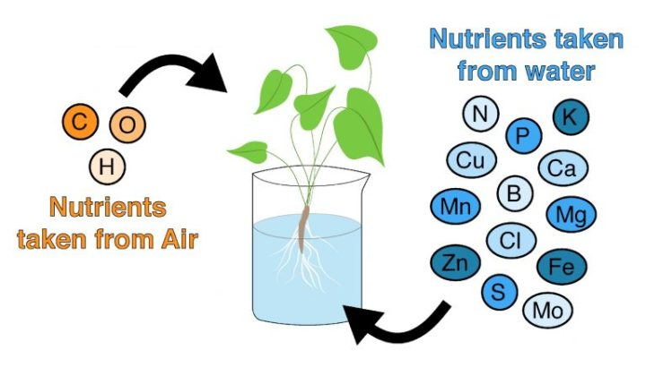

***Figure 1:* Nutrient Solution.** Plants obtain 3 nutrients from the air–carbon, hydrogen, and oxygen–and 13 nutrients from supplemented water: nitrogen, phosphorous, potassium, calcium, magnesium, sulfur, iron, manganese, copper, zinc, boron, chlorine, and molybdate.

In 1937, an American scientist, Dr. W.E. Gericke [described](https://www-ncbi-nlm-nih-gov.ezp-prod1.hul.harvard.edu/pubmed/17732930) how this method of growing plants could be used for agricultural purposes to produce large amounts of crops. Gericke and others demonstrated that the fluid dynamics of water changed the [architecture of plant roots](http://www.plantphysiol.org/content/plantphysiol/109/1/7.full.pdf), which allowed them to uptake nutrients more efficiently than plants grown in soil, causing them to grow larger in a shorter amount of time. Since then, scientists have optimized the nutrient solution, a total of [13 macronutrients and micronutrients](https://university.upstartfarmers.com/blog/overview-hydroponic-nutrient-management), that are added to water for hydroponic farming (Figure 1).

Hydroponic systems today are very sophisticated; there are systems that will monitor the level of nutrients pH, and temperature of the water, and even the amount of light the plants are receiving. There are three main types of hydroponic systems: a nutrient film technique, an Ebb and Flow System, and a Wick system (Figure 2). A [nutrient film hydroponic technique](https://www.youtube.com/watch?v=8sbwypDFVgM) involves plants being grown in a grow tray that it slightly angled and positioned above a reservoir filled with the water-nutrient mix. This allows a thin stream of water to flow across plant roots, allowing the plants to have sufficient water, nutrients and aeration, and then drained back into the reservoir. [The nutrient film technique](https://ag.purdue.edu/hla/fruitveg/Presentations/Langenhoven_Hydroponics_IVGS2016b.pdf) is the most common hydroponic system used today. [Plenty](https://www.plenty.ag/) and [Bowery](https://boweryfarming.com/how-it-works), two of the largest hydroponic farms in the US, use nutrient film techniques to grow lettuce, spinach and other leafy greens. The [Ebb and Flow technique](https://www.youtube.com/watch?v=60uokf3WmTo) allows plants to be flooded with the nutrient-rich water, and after the plant roots uptake nutrients, water is actively drained back into a reservoir to be reused. Finally, a hydroponic [wick system](https://www.youtube.com/watch?v=zlLZbDeAUuc) is the simplest of all, as nutrients are passively given to the plant from a wick or piece of string running up to the plant from the water reservoir. In this system, plants are grown in an inert growing medium such as sand, rock, wool or clay balls that help anchor the plant roots. These different systems are interchangeable, but some systems may be better for growing different types of plants.

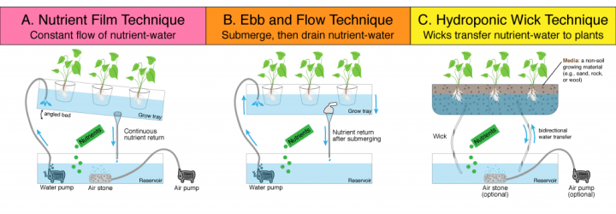***Figure 2:* The three most common techniques for hydroponic farming.** In all approaches, water is fortified with a nutrient solution is stored in a nutrient reservoir. The water is then actively pumped to the grow tray (panels A and B) or it is passively passed to the grow tray (panel C) through a wick. The plant roots grow thicker than those of plants grown in soil, which allow them to uptake nutrients more effectively.

The advantages of using any of these hydroponic systems are manifold. First, since there is no soil, there is no need to worry about having a plot of land, weeds, pathogens living in dirt, or treating the crops with pesticides. Water is also greatly conserved due to the nutrient reservoir because the same water can be reused over and over. Moreover, as most of these hydroponics farms are indoors, food can be produced all year round and even in the middle of a large city, like New York City. Given all of these benefits, we may begin to see more [hydroponic farms sprouting up](https://www.vox.com/energy-and-environment/2017/11/8/16611710/vertical-farms)  across the US and around the world because this method of farming holds much promise to revolutionize agriculture by using less water and other resources.

**Hydroponics for a sustainable future**

Given the need for more sustainable agriculture, there has been a rise in eco-friendly [start-up companies](https://cityos.io/Worlds-Best-Hydroponics-Startups) around the world that are using hydroponic technology to produce crops on a large scale with a technique known as [“Vertical Farming”](https://www.usda.gov/media/blog/2018/08/14/vertical-farming-future) (Figure 3).

Vertical farms are buildings filled with countless levels of hydroponic systems (or nutrient film style planters), growing different crops in an indoor, controlled temperature environment (Figure 3). The largest vertical farm is being built in [Dubai](https://www.smithsonianmag.com/innovation/dubai-will-be-home-to-worlds-biggest-vertical-farm-180969655/), covering 130,000 square feet of land and aiming to produce 6,000 pounds of food per day, [“using 1/2500th the amount of water as an equivalent soil operation”.](https://www.smithsonianmag.com/innovation/dubai-will-be-home-to-worlds-biggest-vertical-farm-180969655/) For a city that imports 85% of their food, this will greatly revolutionize the way the city eats.

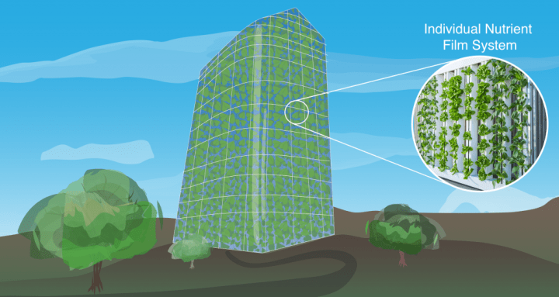***Figure 3:* Vertical Farming.** Vertical Farming is the term for large-scale hydroponic systems that are engineered to house thousands of square feet of growing systems, across many floors in a skyscraper-esque building.

While vertical farms hold a lot of promise, they are expensive to implement, technically difficult on a large scale, and the food produced from these systems is generally more expensive than equivalent soil grown food because of the high-energy costs of maintaining the systems. Even so, the [Associated Press](https://www.apnews.com/Business%20Wire/01a2f713b38a47e6bb9b397754979203) estimates that food produced by hydroponic technology in 2019 is worth $32 billion USD, and this is projected to grow at a rate of 5% per year until 2025.

While hydroponic technology may never replace conventional farming, it is breaking the paradigm of food production; we may see a new generation of modern farmers building green walls inside their houses or community centers to feed families with fresh produce grown all year round.

Source-hydroponics-the-power-of-water-to-grow-food Harvard University

## State wise Area under Organic Farming (Registered under Accredited Certification Bodies), 2010

|  |  |  |  |  |  |
| --- | --- | --- | --- | --- | --- |
| **State Name** | **Certified Cultivated Organic Area (in Hac)** | **Inconversion Cultivated Area ( in Hac)** | **Total area Cultivated under Certification Process ( in Hac)** | **Wild Area (in Hac)** | **Total Cultivated + Wild ( in Hac)** |
| **Andhra Pradesh** | **6070.9** | **6279.72** | **12350.62** | **2000** | **14350.62** |
| Arunachal Pradesh | 243.09 | 0 | 243.09 | 0 | 243.09 |
| Assam | 2001.75 | 45.33 | 2047.08 | 0 | 2047.08 |
| Andaman | 0 | 334.68 | 334.68 | 0 | 334.68 |
| Bihar | 0 | 1303.62 | 1303.62 | 0 | 1303.62 |
| Chhattisgarh | 321.99 | 126.93 | 448.92 | 8000 | 8448.92 |
| Daman & Diu | 0 | 0 | 0 | 0 | 0 |
| Delhi | 127.5 | 138.82 | 266.32 | 0 | 266.32 |
| Goa | 13044.65 | 259.05 | 13303.7 | 0 | 13303.7 |
| Gujarat | 42267.48 | 6251.43 | 48518.91 | 0 | 48518.91 |
| Haryana | 2343.05 | 12420.54 | 14763.6 | 0 | 14763.6 |
| Himachal Pradesh | 2265.46 | 1781.41 | 4046.87 | 627855.12 | 631901.99 |
| Jammu and Kashmir | 640.5 | 135.97 | 776.47 | 0 | 776.47 |
| Karnataka | 9128.01 | 10400.63 | 19528.64 | 69200 | 88728.64 |
| Kerala | 3870.27 | 2727.37 | 6597.65 | 0 | 6597.65 |
| Lakshadweep | 0 | 12.127 | 12.127 | 0 | 12.127 |
| Madhya Pradesh | 270955.69 | 27407.17 | 298362.87 | 2568209 | 2866571.9 |
| Jharkhand | 0 | 0 | 0 | 24300 | 24300 |
| Maharashtra | 124547.03 | 50298.44 | 174845.47 | 2500 | 177345.47 |
| Manipur | 2336.718 | 455.3 | 2792.02 | 0 | 2792.02 |
| Meghalaya | 1564.05 | 855.616 | 2419.66 | 0.0001 | 2419.6661 |
| Mizoram | 4471.6 | 8072.53 | 12544.13 | 0 | 12544.13 |
| Nagaland | 654 | 949.54 | 1603.54 | 0 | 1603.54 |
| Orissa | 16883.73 | 6218.55889 | 23102.29 | 1315.255 | 24417.54 |
| Punjab | 2118.21 | 3907.56 | 6025.78 | 0 | 6025.78 |
| Rajasthan | 57566.93 | 9145.26 | 66712.19 | 151000 | 217712.19 |

|  |  |  |  |  |  |
| --- | --- | --- | --- | --- | --- |
| Sikkim | 1391.03 | 27.3 | 1418.34 | 308 | 1726.34 |
| Tamil Nadu | 3244.61 | 829.982 | 4074.59 | 30803.5 | 34878.092 |
| Tripura | 203.56 | 144.825 | 348.385 | 0 | 348.385 |
| Uttar Pradesh | 17212.42917 | 23800.3974 | 41012.82 | 70632 | 111644.82 |
| Uttaranchal | 9513.756619 | 2073.026 | 11586.78 | 93879.2 | 105465.98 |
| West Bengal | 5014.94 | 1110.78 | 6125.72 | 0 | 6125.721 |
| TOTAL | 600003 | 177513.9811 | 777516.882 | 3650002.1 | 4427519.1 |

*Source: Agriculture and Processed Food Products Export Development Authority, 2010-11*

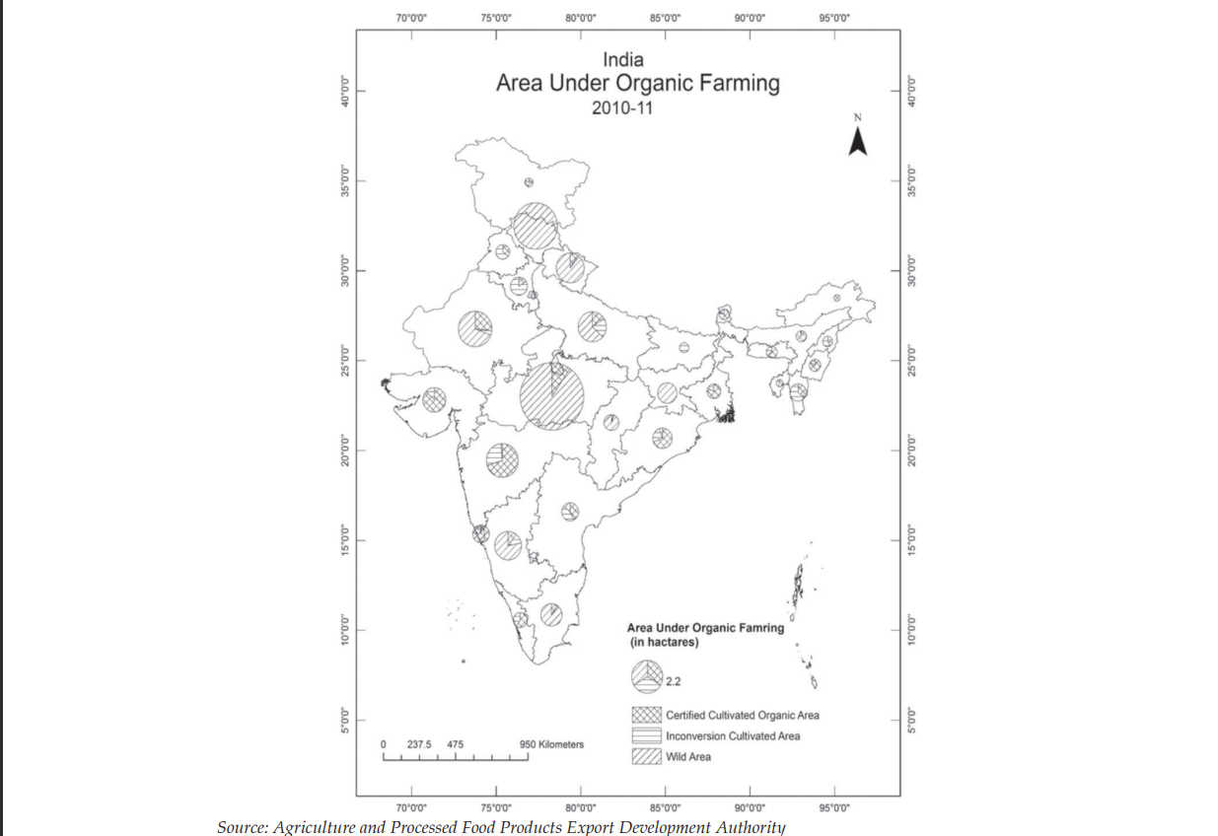

**Study-11**

GROWTH OF ORGANIC FARMING:-

**❖In order to satisfy the increasing demand of organic products the organic farming sector in India has substantially increased over the count of year.**

**❖India ranks 33 in world in terms of area under organic farming**

**❖India rank 88" in terms of the ratio of agriculture land under organic crop to total farming area ❖Madhya Pradesh has highest area under organic farming (1 m or 52%)**

**❖ Maharashtra is at second ( O mho33.6%)**

**❖ Orissa is third (0.67mhar or 9.7%)**

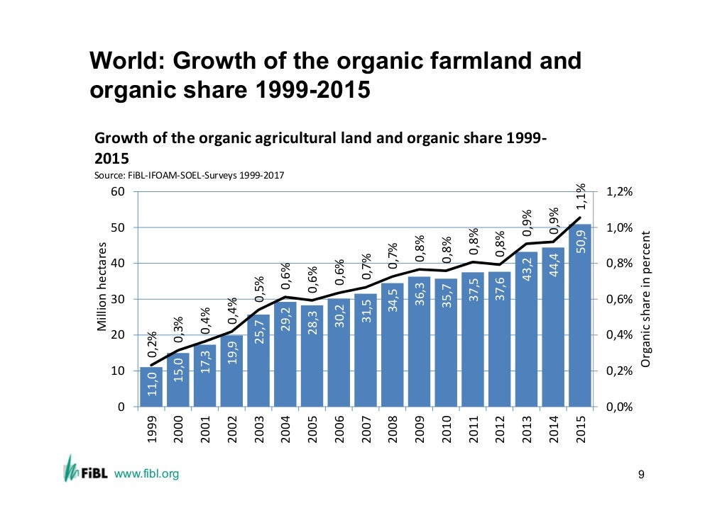

**Study-12**

Sikkim Case:

* On 9 January 2016 Honorable prime minister declared Sikkim as First Organic State in India

Sikkim win the Future Policy Award, a prize given to the best global policies in the field of agroecology, organised by the FAO together with the World Future Council and IFOAM Organics International

* The State was awarded with a citation from Agriculture Today in the year 2009 for 'Outstanding Performance in Horticulture
* Sikkim received Development received UN word for becoming world's first Organic State, Beats 25 countries.

The process of converting into a 100% organic state was fast-tracked in2010 with the launch of the Organic Mission.

|  |  |
| --- | --- |
| **YEAR EVENT OCCURED** | |
| **2003** | Sikkim begins discouraging use of  chemicals. reduces fertilizer subsidy by 10%. |
| **2003-2009** | State adopts 396 villages as bio-villages to test organic input. |
| **2008-2009** | About 8000 land is certified as organic.  ..vermi culture hatcheries and krishi vigyan Kendra was established. |
| **2010** | Sikkim organic mission is launched to fast track conversion of Sikkim in to100%  organic sale. |
| **2010-2011** | More than 18,234 ha of land is certified . Automated green house was established. |
| **2011-2012** | 19,188 ha land is certified. |
| **2015** | Entire agriculture area in the states converted in to certified organic. |
| **2016** | Sikkim is formally declared a 100% Organic state |
|  | Now Sikkim is a organic model of India |
|  |  |
|  |  |

# BENEFIT:OLOGICAL

* + Produces healthy soil
  + Fight against effect of global warming
  + Combat erosion
  + Water Health
  + Discourage algal bloom
  + Animals health
  + Encourage Biodiversity

# BENEFIT: ECONOMICAL

* + - Reduction in production cost
    - Increased farmers Income
    - . Better purchasing power
    - Access to Organic markets with premium prices Higher bargaining power
    - . High exports Meaning
    - Stabilization in financial ret with crop diversification as the risk of main crop failure is reduced
    - Poverty eradication

**Study-13**

**Organic farming and sustainability:**

One of the main advantages of producing organic food is that farmers can reduce greenhouse gases, such as methane and nitrous oxide, cast into the atmosphere. It also preserves culture and agriculture while providing healthier food sources. A survey led by researchers at the University of California, Davis, revealed that food produced by organic methods contains up to 58% more polyphenolics (an antioxidant) than conventionally grown food ([Fell, 2003](https://www.sciencedirect.com/science/article/pii/S2949911923000059#bib39); [Faller, 2010](https://www.sciencedirect.com/science/article/pii/S2949911923000059#bib35)). The researchers concluded that the higher levels of polyphenolics, which plants use as a natural defense system, could be attributed to the more significant number of pests they must fight. It is another way of saying that pesticides and herbicides could lower a plant's rate of phenolic production. The synthetic fertilizers that many farmers use also require many fossil fuels during the manufacturing process, so less synthetic fertilizer means fewer fossil fuels are being burned. Chemical fertilizers threaten the environment, and chemicals can often enter local ecosystems, harming animals and polluting rivers. Organic farming does not pose such risks to the natural environment. One of the main reasons for farming is to protect and maintain the health of the soil. To do this, farmers use nutrient-rich composts containing only organic materials, add minerals like rock phosphate and greensand, and practice crop rotation. Most people have an awful perception of pesticides and other chemicals being used in the food they will be eating; therefore, producing organic food can ease consumer fears and increase consumption. Water has been another big issues become lately. Because no chemicals are used in organic farming, the possible [groundwater contamination](https://www.sciencedirect.com/topics/agricultural-and-biological-sciences/groundwater-contamination) is nonexistent. Ample opportunities for rural jobs, and fewer external costs for unnecessary pesticides, fertilizers, etc ([Chaichi et al., 2018](https://www.sciencedirect.com/science/article/pii/S2949911923000059" \l "bib14); [Merah et al., 2021](https://www.sciencedirect.com/science/article/pii/S2949911923000059#bib77); [Mohammedi et al., 2022](https://www.sciencedirect.com/science/article/pii/S2949911923000059#bib78)). Those are the main advantages of organic farming ([Zhou and Ding, 2022](https://www.sciencedirect.com/science/article/pii/S2949911923000059#bib139)).

Ending world hunger, achieving food security, and promoting [sustainable agriculture](https://www.sciencedirect.com/topics/agricultural-and-biological-sciences/sustainable-agriculture) are the main targets of sustainable development goals (SDGs). When the SDGs are taken as a whole, Agriculture is contributing to all the 17 sustainable goals either directly or indirectly ([Lu and Wu, 2022](https://www.sciencedirect.com/science/article/pii/S2949911923000059#bib72)). For instance, we cannot end poverty without ensuring food security. To achieve the second goal of the SDGs, there should be sufficient, safe, and affordable food for all. Good health starts with good nutrition. We cannot provide quality education without any nutritious food since nutritious food is critical to learning. Gender equity could boost agricultural productivity. Because if any country has an economic crisis most of the time they feed according to gender. Sustainable agriculture has the potential to address water security. When people eat healthy food, they think about clean water and sanitation ([Linderhof et al., 2021](https://www.sciencedirect.com/science/article/pii/S2949911923000059#bib70)). Organic agriculture helps to overcome dependence on fossil fuels. Most people like to have decent work when agriculture grows low, it affects the economic growth of most agriculture-based countries ([UNEP, 2011](https://www.sciencedirect.com/science/article/pii/S2949911923000059#bib126)). Industry innovation and infrastructure facilities will increase with customer-friendly agricultural products. Land reforms can give fairer access to rural land. When organic farming is practice in any community, they will be healthy physically, mentally, and economically. Achieving Food security involves reducing waste. Best agriculture practices are key in responding to climate change. Fish provide 20% of daily [animal protein](https://www.sciencedirect.com/topics/agricultural-and-biological-sciences/animal-proteins). Forests contain over 80% of the world's terrestrial biodiversity ([Ukhurebor and Aidonojie, 2021](https://www.sciencedirect.com/science/article/pii/S2949911923000059" \l "bib125)). If any in risk to food security, there are so many conflicts between the poor and the rich. Ending hunger can contribute in a high position to establishing peace and justice and strong institution. It is evident how organic agriculture contributes to sustainable development goals. One major disadvantage of organic farming is the high costs and time consumption in the process. It might not be sustainable/profitable. Many studies conducted on organic farming have concluded that the yields provided are not productive enough to be profitable. The researchers found that organic yields were 25% lower than those of conventional farming ([Roberto, 2022](https://www.sciencedirect.com/science/article/pii/S2949911923000059#bib101)). This is what Sri Lankan experience these days with improper policy interventions, which resulted in a reduction in productivity. Farming can be a lot more labor-intensive, and the cost of organic feed is much higher than non-organic feed. These costs are passed on to the consumer making organic food more expensive to buy than conventionally produced food. Whilst many people are more than willing to pay more for their food because it is organic, during times of hardship and recession, people are less likely to buy organic when they can get the same food for a cheaper price. Organic farming also requires far more land to grow the same amount of produce as conventional farming does because chemicals are not used to produce high-yield crops. Sustainable agriculture adopting [Agroforestry](https://www.sciencedirect.com/topics/agricultural-and-biological-sciences/agroforestry) Practices. They were applying [Integrated Pest Management](https://www.sciencedirect.com/topics/agricultural-and-biological-sciences/integrated-pest-management). Farmers can use biological and mechanical methods to keep unwanted animals and insects from their crops. Chives, sage, and mint plants are natural insecticides, that can use as [biological pest control](https://www.sciencedirect.com/topics/agricultural-and-biological-sciences/biological-pest-control). [Aquaponics](https://www.sciencedirect.com/topics/agricultural-and-biological-sciences/aquaponics) is when people grow fish and vegetables in a mutually beneficial system sharing water and nutrients. [Hydroponic](https://www.sciencedirect.com/topics/agricultural-and-biological-sciences/hydroponics) farmers grow plants using [fertigated](https://www.sciencedirect.com/topics/agricultural-and-biological-sciences/fertigation) water. They grow plants without soil and instead use materials like clay balls, coconut hair, and fabric. Sustainable farmers avoid [soil erosion](https://www.sciencedirect.com/topics/agricultural-and-biological-sciences/soil-erosion). Farmers can take care of the ecosystem by minimizing their use of fertilizers and pesticides so that runoff from their farms does not contribute to water pollution. Instead of using [sprinklers](https://www.sciencedirect.com/topics/agricultural-and-biological-sciences/sprinklers), for example, farmers seeking to conserve water can adapt to [drip irrigation](https://www.sciencedirect.com/topics/agricultural-and-biological-sciences/drip-irrigation) to irrigate their plants. Cover crops to help them to handle manure and to graze tame animals like cows, goats, and sheep.

**Study-14**

**Soil microbial biomass in organic farming:**

Organic farming systems avoid applications of synthetic fertilizers and pesticides, promote organic inputs and recycling of nutrients, and emphasize cropping system design and biological processes for pest management (RIGBY & CACERES, 2001). These practices promote, mainly, the improvement of soil quality and the maintenance of the environmental quality. In this way, they may thus reduce some negative effects attributed to conventional farming (REGANOLD et al., 1987).

Soil is a dynamic, living, natural body that is vital to the function of terrestrial ecosystems and represents a unique balance between physical, chemical and biological factors. Soil quality is the capacity of a specific kind of soil to function, within natural or managed ecosystem boundaries, to sustain plant and animal growth, maintain or improve water and air quality, and support human health and habitation (DORAN & PARKIN, 1994). Additionally, soil is a complex system, in which, plant, macro, meso and microorganisms dispute water and nutrient sources for survival and whose physical, chemical and biological properties shows high spacial temporal changes (MELO, 1994).

In this context, microbial biomass has been suggested as indicator of soil quality. The microbial biomass is the main living component of soil organic matter and promotes fundamental functions for the maintenance or improvement of soil quality, being primarily affected by the changes in the soil use and management. Thus, the agricultural practices in organic farming can influence the soil microbial biomass and promote changes in soil quality.

Organic farming system

Organic farming can be defined as an approach to agriculture where the aim is to create and integrated, human, environmentally and economically sustainable agricultural production systems. Organic agriculture is distinct from conventional agriculture through alternative agricultural practices, world view and values (WATSON et al., 2006). Maximum reliance is placed on locally or farm-derived renewable resources and the management of self-regulating ecological and biological processes and interactions in order to provide acceptable levels of crop, livestock and human nutrition, protection from pests and diseases, and an appropriate return to the human and other resources employed.

In the world, organic farming is regulated and legalized by the International Federation of Organic Agriculture Movements (IFOAM). In the last decade, organic farming system is gaining worldwide acceptance and has been expanding at annual rate of 20%, accounting for over 24 million hectares worldwide (LOTTER, 2003). Australia has the largest land area under organic management (about 10 million hectares), followed by Argentina (about 3 million hectares), Italy (about 1.2 million hectares), and the USA (about 1 million hectares) (WILLER & YUSSEFI, 2004). European countries have the highest proportion of land under organic management. For instance, organic land accounts for about 12% of the total agricultural area in Austria, 10% in Switzerland, 8% in Italy, and 7% in Finland (WILLER & YUSSEFI, 2004). It is estimated that by 2010 organically farmed land will occupy 10-20% of total agricultural land areas in many European countries (GREENE & KREMEN, 2003). In the US, the organic market grew around 20% annually between 2002 and 2007 (WILLER & YUSSEFI, 2004). Brazil counts as one of the leading countries worldwide in organic farming (~850,000ha) and occupies the 6th position in the world (ARAÚJO et al., 2008).

The main characteristics of organic farming include: a) Protecting the long-term fertility of soils by maintaining high level of organic matter content and increasing soil biological activity; b) Providing crop nutrients indirectly using relatively insoluble nutrient sources which are slowly available to plant uptake by the action of soil micro-organisms; c) Nitrogen self-sufficiency through the use of legumes and biological nitrogen fixation, as well as effective recycling of organic materials including crop residues and livestock manures; d) Weed, disease and pest control relying primarily on crop rotations, natural predators, diversity, organic manure, resistant varieties and limited (preferably minimal) thermal, biological and chemical intervention; e) The extensive management of livestock, paying full regard to their evolutionary adaptations, behavioral needs and animal welfare issues with respect to nutrition, housing, health, breeding and rearing; f) Careful attention to the impact of the farming system on the wider environment and the conservation of wildlife and natural habitats.

On the other hand, the main characteristics of conventional agriculture are high inputs of chemical fertilizers and pesticides (agrochemicals). In the last decades, intensive use of agrochemicals has increased the toxicity in soils and also has degraded its status. Organic farming is becoming a major tool for sustaining the soil quality degraded by synthetic chemicals by increasing crop production and therefore, the use of bio-agents as biofertilizers or biopesticides which is an integral part of organic farming especially in vegetable cultivation (TRUU et al., 2008).

Overview of studies:

|  |  |  |  |  |  |
| --- | --- | --- | --- | --- | --- |
| S. No. | Objectives | Results | Major highlights | Techniques used | Remarks |
| Study 1 | Reducing use of chemicals. | not reached all farmers. | Knowledge gap. | Natural fertilizers. | It should reach farmers with affordable solutions. |
| Study 2 | Increasing farmers’s income. | Many are unaware about these. | Gives extra support to farmers. | Government help. | Farmers should me made aware of these schemes for maximum benefit. |
| Study 3 | Reducing water usage. | They were able to make farmers aware. | Farming with chemicals requires a lot of water even after reducing it using different techniques. | Dripping method, sprinkler method, etc. | Switching to organic method and farming as they require less water and after few cycles land automatically becomes moisturized. |
| Study 4 |  | They found that organic farming systems had lower yield than conventional | Yields of organic farming were 20% lower in developed countries | Numerous studies were used to compare crop yield | Without right information organic farming cannot give desired output |
| Study 5 | Support biodiversity by means of organic farming | It was found out the organic farming provides more biodiversity | Performing organic farming provides beneficial effects on ecosystem, showing wide range of positive effects | Use of organic farming methods like use of natural fertilizers | Overall effect of organic farming was positive |
| Study 6 | (i)To reduce the ecological footprint of agriculture while maintaining commodity production  (ii)Pest control by use of organic farming | This study provides evidence that organic farming can enhance pest control and suggests that organic farming offers a way to reduce the use of synthetic pesticides | (i) organic farming promotes overall biological pest control potential, (ii) organic farming has higher levels of overall pest infestations but (iii) that this effect strongly depends on the pest type | Practicing organic farming without use of pesticides | Farmers should be made aware of such benefits of organic farming and these studies must reach out to them |
| Study 7 | Increasing their yields. | These new technologies helps farmers overcome these challenges using precision agriculture techniques. | It optimize activities such as planting, irrigation, and crop scouting. | Precision agriculture and smart agriculture. | Without aware of the precision techniques it can’t be helped for the farmers. |
| Study 8 | Reducing of human errors | Section control farmers can benefit from removing the human errors that are bound to happen when dealing with large farmland areas. | It ensures that crops are planted correctly and at the correct depth, preventing seed losses due to incorrect planting. | The technology does this by precision mapping the field, which is then used to guide farm machinery. | We want aware of the machine that is used otherwise it can make huge loss than humans. |
| Study 9 | Data collection and analysis | Farmers can easily collect data about their crops, Weather conditions,etc.., using Iot devices. | This data can be used to improve farm management decisions, and This information can help farmers adjust their inputs and manage accordingly. | Human effort and machine effort | Misuse of data or In case of human error whole effort will be useless. |
| Study 10 | Aquaponics and its implementation | This uses very less water showed high yield. | In case of drought and water scarcity this is the best available technique. | Not all types of crops can be grown. | Areas with less water should implement this technique. |
| Study 11 | Growth of organic farming. | With increasing organic farming, India ranks 33 in the world. | With increasing demand India is increasing production. | We are still very slow as per our country size and population. | India needs to work faster to compete and maintain sustainability. |
| Study 12 | Learn from Sikkim | With proper planning and implementation Sikkim became the first organic state of India. | It has increased the overall per capita income of people of Sikkim, | Sikkim brand is so strong that others are not considered as good as them in organic food industry. | Sikkim model has to be studied and used all over India. |

## TASK PERFORMED

## 1. Introduction

Full Stack Developers are responsible for designing and developing websites and platforms . They work with design teams to ensure that user interactions on web pages are intuitive and engaging.

* Developing front end website architecture.
* Designing user interactions on web pages.
* Developing back-end website applications.
* Creating servers and databases for functionality.
* Ensuring cross-platform optimization for mobile phones.
* Ensuring responsibilities of applications.
* Seeing through a project from conception to finished product.
* Designing and developing APIs.
* Meeting both technical and consumer needs.
* Staying abreast of development in web application and programming languages.

### 2. Technology used

* DJANGO
* MYSQL
* HTML,CSS,JS

### System Analysis and Design

1. **Existing System**

The existing system is very traditional as the Data Management is very complex. Here, buying and selling of products is done manually. All the details of the agricultural product to be sold or purchased are stored manually. Sellers and Buyers are not able to get the complete information about the product.

1. **Disadvantages of the Existing System**

* No category-wise classification of Agricultural products.
* Insufficiency in querying details

1. **Proposed System**

In the proposed system, buyers or farmers can directly register into the site and sell/buy the product.

Farmers can open their site and can sell the agricultural products online.

1. **Advantages of the Proposed System**
   * Agricultural products are classified on the basis of their category.
   * Avoids efforts in maintaining the data.
   * Easy and interactive.

##### Flow Chart :

**production calculator:**

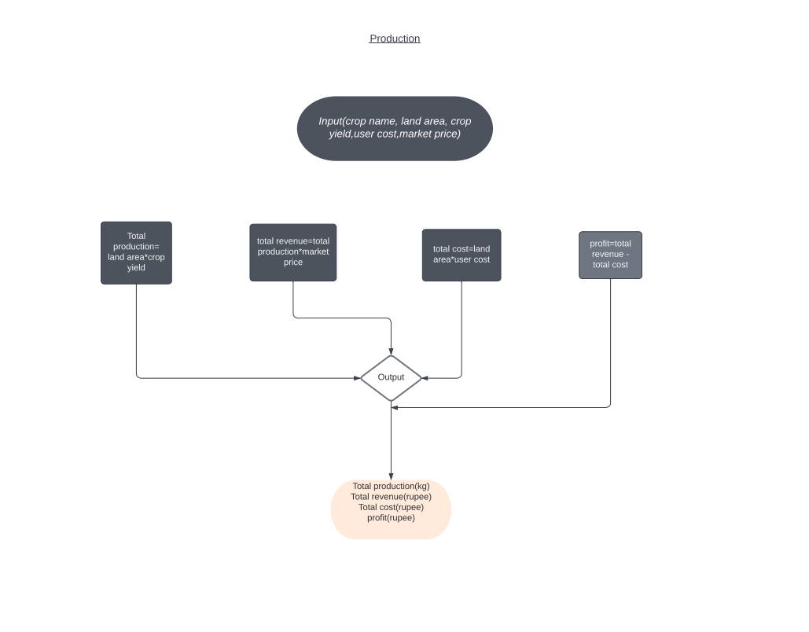

**soil identification:**

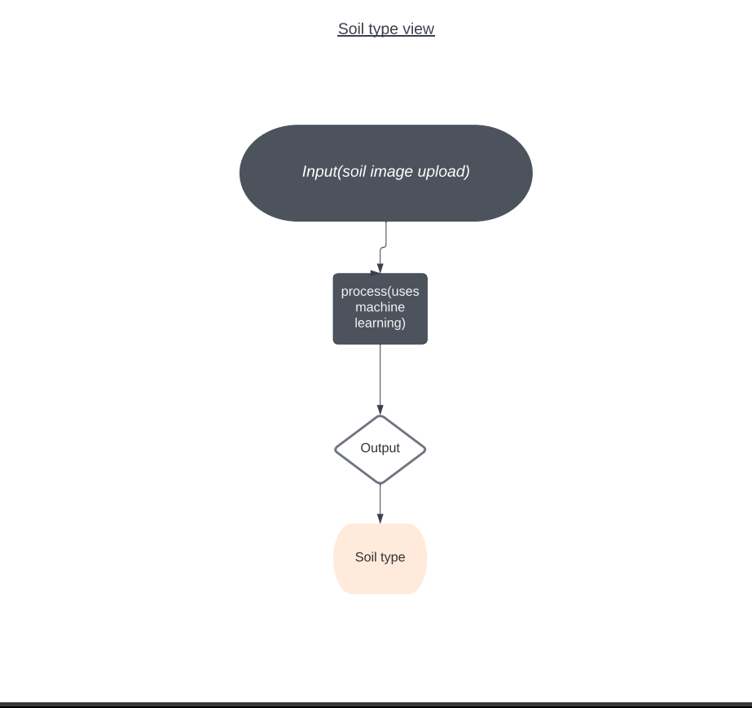

**loan calculator:**

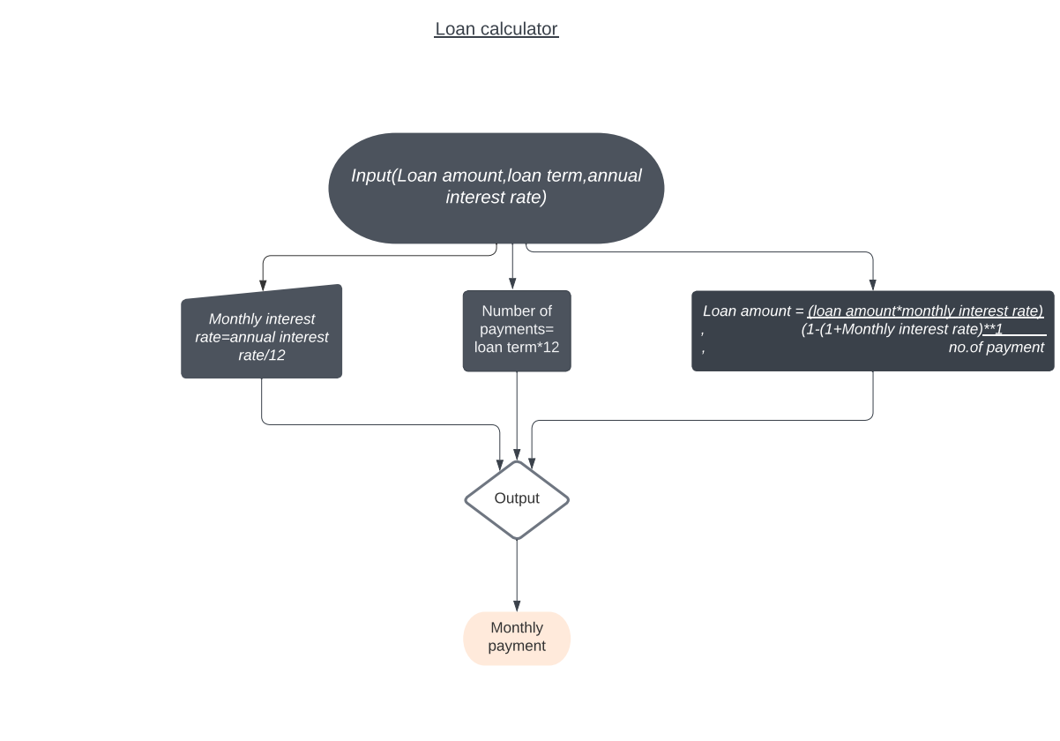

**crop yield calculator:**

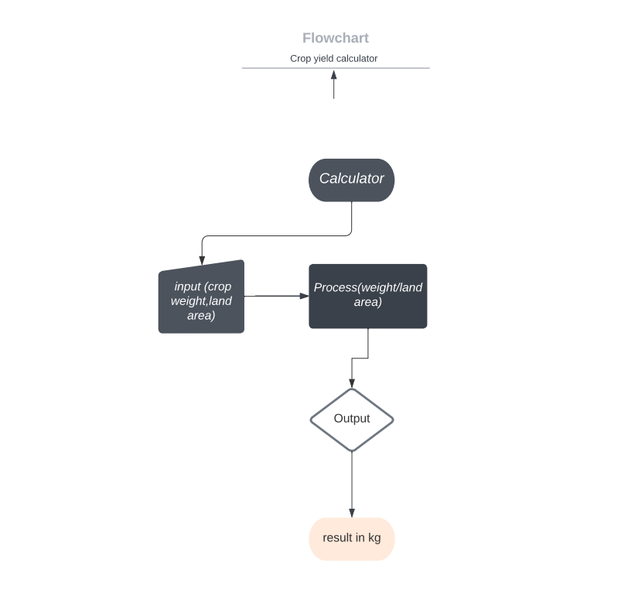

Weather Api:

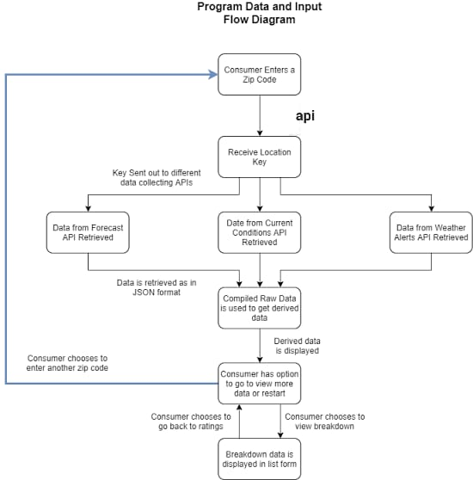

##### 4.5.1 Modules

This project is modularized as the following:

1. Admin.

2. Seller.

3. Customer.

4. Produce.

5. Purchase request.

6. Purchase order bill.

7. Farmer Product.

8. Weather API.

9. Soil Classification System.

10. Calculators {Loan, Yield, Production}.

11. Articles Studies on New Farming Technologies.

12. Government Schemes.

13. Videos Section.

17

**4.6 Screen Shots**

**Backend:**





**Landing page :**

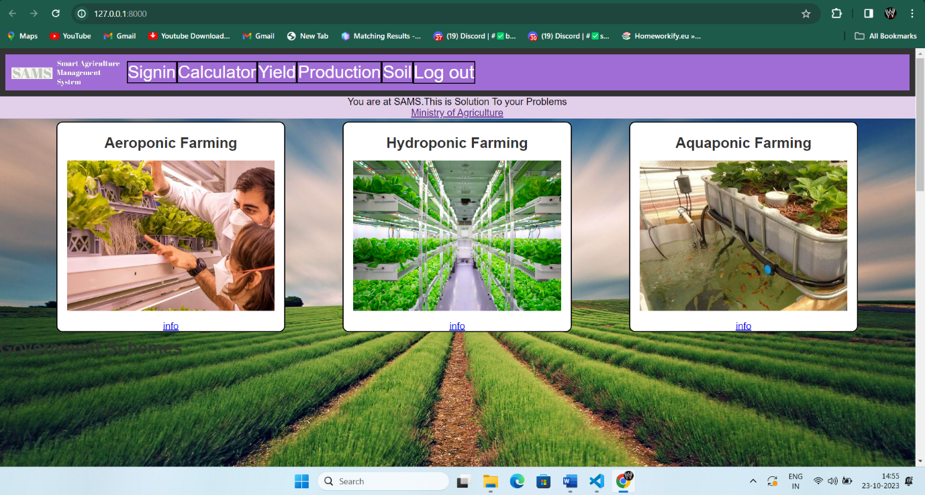

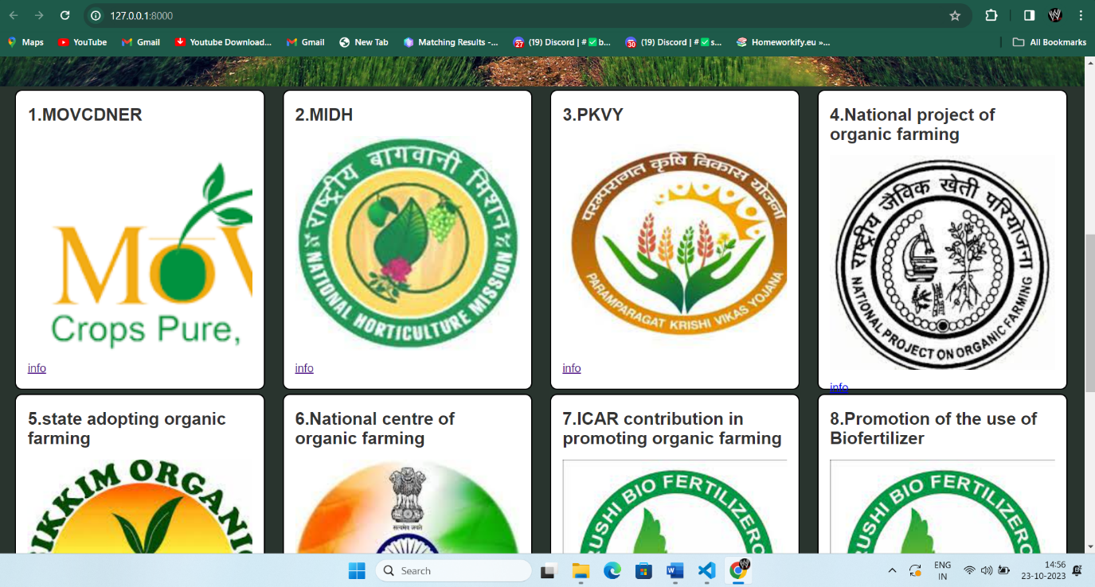

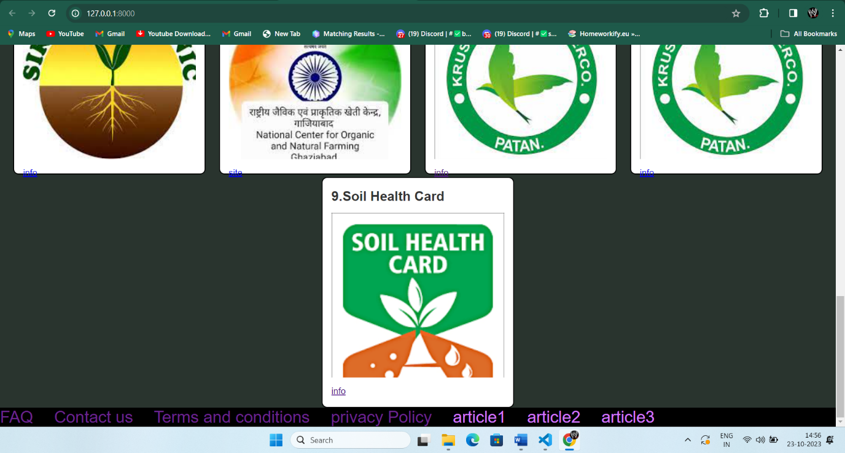

**Customer/Farmer (Register/Login),Staff login:**



**Farmer Registration pannel:**

### 

19

**Calculators:**

**Loan:**

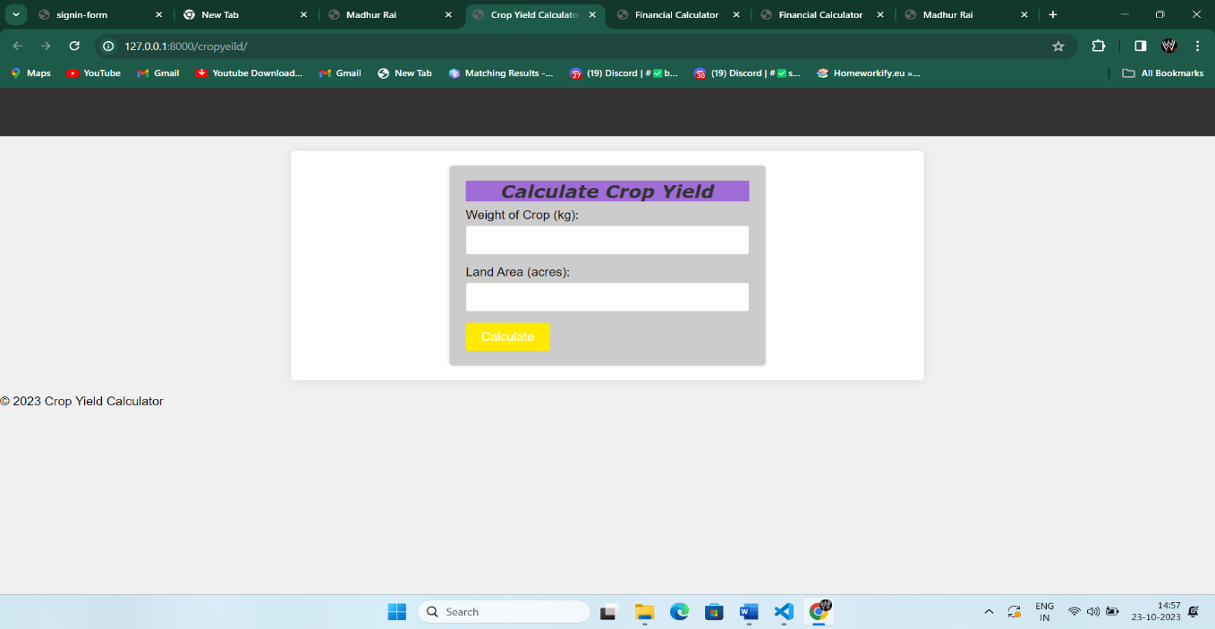

### Yield calculator:

**Production calculator:**

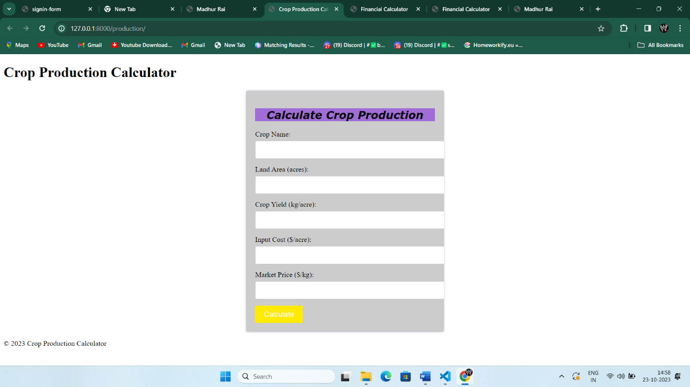

**Soil identification:**

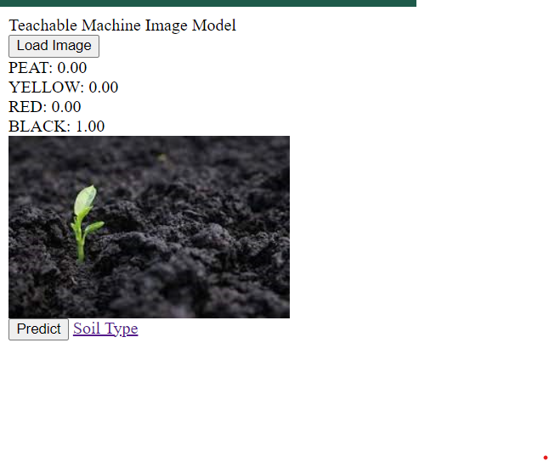

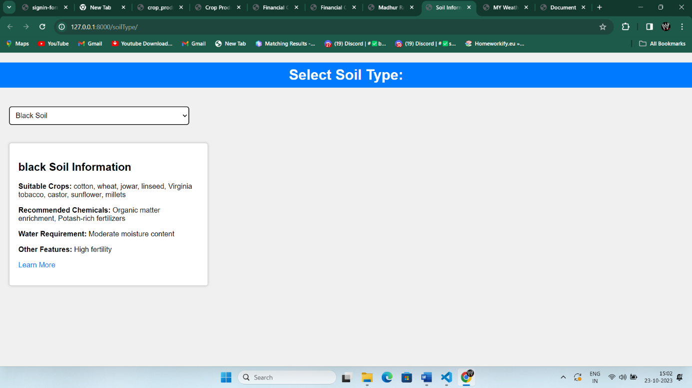

**Weather Api:**

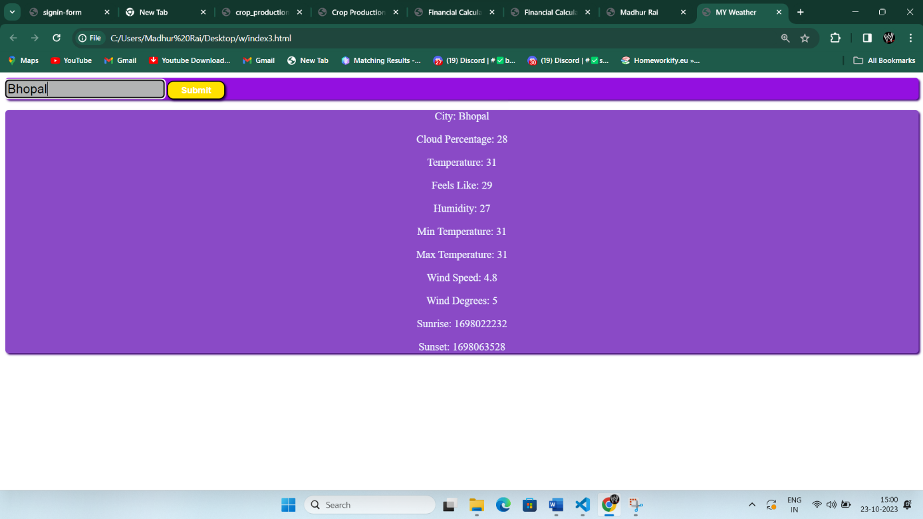

**Videos:**

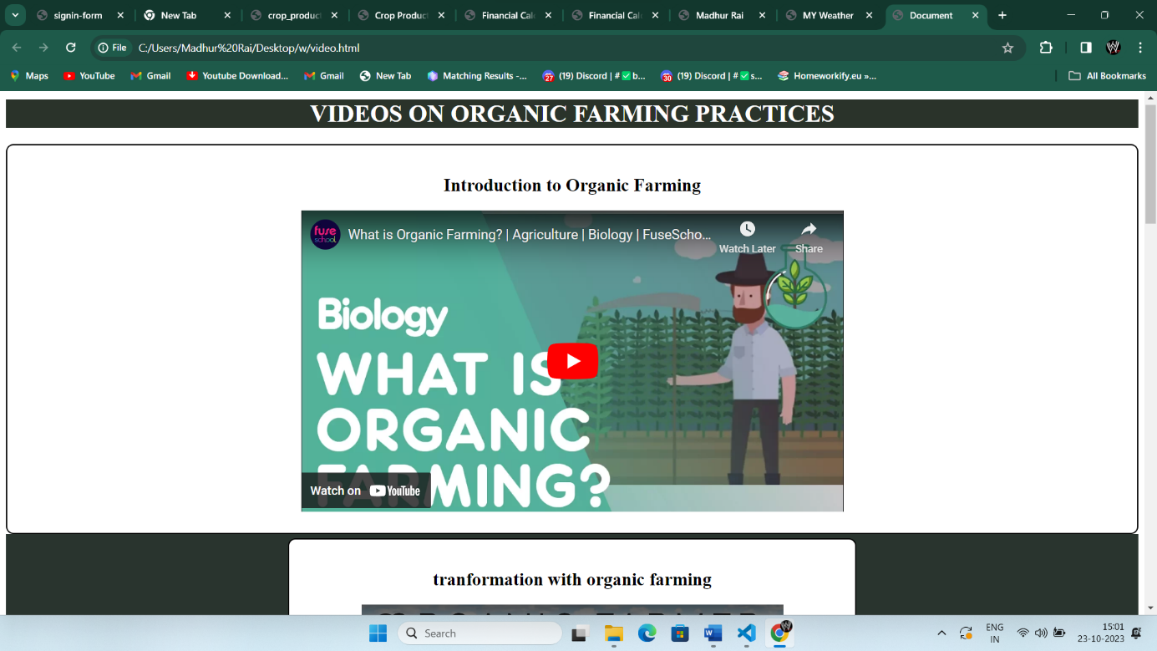

## REFLECTION NOTES

### Experience

the term traditionally refers to real-world work experiences in which students fulfill short-term positions within a group in order to gain hands-on experience and develop career specific skills.

* Worked on communication skills for presentations.
* The effective ways of communicating with group members, raising the level of self-confidence.
* The skill of making the right decision for a given problem that occurs .

### Worked on development skills.

### Technical Outcomes

The outcomes of attending project exhibition as per the curriculum are in terms of technical knowledge. The outcomes can be summed up as follows:

* The communication of ideas and thoughts regarding a problem with the group members gave us high confidence and boosted up the decision making capabilities.
* Web Development being one of the top domains in the current scenario, working on such a domain specifically can helped us enhance our knowledge base in this area.
* Derive information from data and implement data into application.
* Implemented basic javascript and created visualizations .
* Find and use code packages based on their documentation to produce working results in a project.

**Results and discussions:**

We have made a platform for farmers to get educated about the importance and need of organic farming with new technologies.

Here they can get idea of their soil type and the variety of crops they can grow as per their region , soil and ,market needs.

We have provided them with various calculators to get an idea and plan accordingly.

To save them from debt traps, we provide them with information like how much interest they have to pay monthly, we introduce them with various government schemes for them.

Taking Sikkim model of organic farming in consideration, we will provide them platform to reach the consumers of organic yield through our websites, where they can do their business effectively.

We aim to reduce the harm caused by conventional farming that uses chemicals and a huge amount of water, that eventually kills the soil life. We aim to build a safe future for all by helping farmers to shift to organic ways of farming.

## CONCLUSION

With the theoretical inclination of syllabus, it becomes very essential to take the at most advantage of any opportunity of gaining practical experience that comes along. The building blocks of this project “Agriculture Management System” is one of these opportunities. It gave the requisite practical knowledge to supplement the already taught theoretical concepts thus making us more competent as a computer engineer. The project has also helped in understanding the following aspects of project development.

•The planning that goes into implementing a project.

•The importance of proper planning and an organized methodology

Therefore The name Agriculture Management System indicates Intelligent Agriculture.This is a model farmer management website application and site helps the farmers to sell their agricultural produce online and suggest best in practice farming processes.This enables wholesalers and retailers to expand their business.

We stand as a farmer’s friend and working to make their income high. We are a platform that provides farmer with multiple applications at a single place.

As the world is shifting to organic farming this is a place that can make farmers comfortable with the organic farming. This will help them to adapt to changes and be their guide.

**Future Scope**

A lot of features can be added that can improve faming yields to a large scale being sustainable A few of the features that can implemented so that it will be helpful for farmers to carry out farming with ease

* Crop decease identification system using machine learning we can make a model that will be efficient and can predict the decease of the crop and farmer can be able to save thew crop for infection, this feature will be able to save a lot of yield from being devastated by decease.
* Crop suggestion System this system can predict the crop that the farmer can grow on their farm based on the condition of the land and area it can suggest the best suitable crop that can be grown under those circumstances.
* Based on the level of nitrogen, phosphorus, sodium, rainfall level, ph of the soil …we can predict the suitable crop using the database
* Using these models we can also suggest the natural fertilizer and important measures that are required to grow the particular crop that is suitable for the farmer
* We will be enhancing payment methods and will work on the security of the website.
* We will integrate government websites to our website and map based data will be improved.

## BIBLIOGRAPHY

**1.Agriculture through the Laboratory and School Garden,** 1st 1905, 3rd 1913, byJackson & Daugherty, Orange Judd Pub. 450 pages, tables & illus.

**2.Gardening for Profit**, Peter Henderson, first ed. 1887, Orange Judd, 2nd ed.

1991American Botanist, diverse pagination +/- 300.

1. **Fields, Factories and Workshops of Tomorrow, 1899, 1909, 1919, 1968 and 1985**

,Peter Kropotkin writer and Colin Ward editor; Chapter 2, Pages 47-116, Freedom Press,London.

1. **The Story of Gardening**, Martin Hoyles, 1991, Journeyman Press, 315 pp., illustrated.

5.**Greening of Public Housing**, 25th Anniversary Flier in 1957 by the NYC PublicHousing Authority.

**6.To Dwell is to Garden,** 1987, Warner, S.B. pp. 13 - 20 NorthEastern Univ. Press [late1900s to 1960s].

**7.Charity Review 1898**, Speirs et al, Detroit Mayor Hazen CS Pingree, [vacant lot farmingin 16 cities including Detroit in the1890s, bibliography].

## APPENDIX

### Appendix A: Abbreviation

* HTML: Hyper Text Markup Language
* CSS: Cascading Style Sheets.
* API: Application Programable Interface
* R&D: Research and Development
* IT: Information Technology

**REFERENCE**

<https://www.lettusgrow.com>

<https://www.harvard.edu/>

<https://indjst.org>

Sikkimorganicmission.gov.in

<https://eos.com/blog/crop-yield-increase/>

<https://intellias.com/artificial-intelligence-in-agriculture/>

<https://www.sciencedirect.com/science/article/pii/S0168169918308913>

<https://www.unep.org/resources/report/chemicals-plastics-technical-report>

<https://www.drishtiias.com/to-the-points/paper3/doubling-farmers-income>

<https://www.sciencedirect.com/science/article/pii/S0167880922000640>

<https://go.gale.com/ps/i.do?id=GALE%7CA290293634&sid=googleScholar&v=2.1&it=r&linkaccess=abs&issn=00280836&p=HRCA&sw=w>

<https://ageconsearch.umn.edu/record/303542/>

<https://www.nature.com/articles/s41893-018-0102-4>

<https://www.sciencedirect.com/science/article/pii/S2949911923000059>

<https://go.gale.com/ps/i.do?id=GALE%7CA290293634&sid=googleScholar&v=2.1&it=r&linkaccess=abs&issn=00280836&p=HRCA&sw=w&userGroupName=anon%7E3af2826c&aty=open-web-entry>

<https://orgprints.org/19668/1/653_OEL_biodiversity_Rahmann_LBF_3_11.pdf>

<https://www.nature.com/articles/s41893-018-0102-4>

<https://www.scielo.br/j/cr/a/ZKZBMzq9Sx4skwWXQTshTJm/>